SPCEDS Maths Long Term Plan
 | Term 1 | Term 2 | Term 3 | Term 4 | Term 5 | Term 6
EYFS | White Rose – Just like me!  During this block of learning, children will know, understand and be able to do the following:  - Match:  - Find and match objects which are the same.  - Sort:  - Know that objects can be sorted based on attributes such as colour, size, or shape.  - Know how different sets are the same or different based on how they have been sorted.  - Compare amounts:  - know that sets we have sorted can be compared and ordered.  - Understand that when comparing sets, they can have the same, more, or fewer items.  - Compare size:  - Know that objects can be compared by their size (use language like big, small, little, large and begin to introduce language such as tall, long, and short).  - Make simple patterns:  - Copy, complete and continue a simple pattern (patterns with at least 3 full units of repeat).  White Rose – It’s me 1,2,3  During this block of learning, children will know, understand and be able to do the following:  - Represent 1,2 and 3:  - Identify 1,2 and 3 in representations.  - Know how to subitise or count to work out how many.  - Know number names and match them to numerals and quantities.  - Count to three objects in different arrangements, knowing that the final number they say names the quantity of the set.  - Mark-make to represent 1, 2 and 3.  - Compare 1, 2 and 3:  - Know that, when we count, each number is one more than the number before.  - Know that, when we count back, each number is one less than the number before.  - Composition of 1,2 and 3:  - know that all numbers are made up of smaller numbers.  - Know how 1, 2 and 3 are composed.  - Circles and triangles:  - Know that circles have one curved side and triangles have three straight sides.  - Recognise shapes in different contexts and through different orientations.  White Rose – Light and Dark  During this block of learning, children will know, understand and be able to do the following:  - The Number Four:  - Know how to count on or back from 4.  - Know how to count or subitise sets of up to 4 objects.  - Know how to match the number names to the numerals and quantities.  - Use mark-making to represent numbers to 4.  - The Number Five:  - Know how to subitise up to 5 items.  - Know how to count forwards and backwards using the counting principles.  - Know how to represent up to 5 objects on a fives frame and understand that when the frame is full there are 5.  - Link to children’s birthdays as most will be turning 5.  - One more, one less:  - Know how to count, subitise and compare when exploring one more and one less.  - Understand the link between one more, one less and counting forwards and backwards.  - Shapes with 4 sides:  - Know that squares and rectangles have 4 straight sides and 4 corners.  - Recognise shapes in everyday items.  - Night and Day:  - Talk about night and day.  - Know the order of key events in their day.  - Know key language to describe when events happen e.g., day, night, morning, afternoon, before, after, today, tomorrow. Know how to measure time in simple ways e.g., 10 sleeps to go. |  | Alive in Five!  During this block of learning, children will know, understand and be able to do the following:  - Zero:  - Know the number name ‘zero’ and understand that the numeral ‘0’ is used to represent this.  - Compare numbers to 5:  - Continue to understand that when comparing numbers, one quantity can be more than, the same as or fewer than another quantity (with numbers up to 5).  - Composition of 4 and 5:  - Continue to understand that all numbers are made of smaller numbers.  - Know the different compositions of 4 and 5.  - Compare mass:  - Link the idea of weight to their experiences of carrying heavy and light things.  - Compare two item’s weights, estimating which is heavier and using a balance scale to check.  - Know and use the language to describe mass e.g., heavy, heavier than, heaviest, light, lighter than, lightest to compare items.  - Compare capacity:  - Know when something is full and empty; use this understanding to know when something is half full, nearly full, or nearly empty.  Growing 6,7,8  During this block of learning, children will know, understand and be able to do the following:  - 6, 7 and 8:  - Apply the counting principles when counting to 6, 7 and 8.  - Know how to represent 6, 7 and 8 in different ways.  - Know how to count out the required number of objects from a larger group of items.  - Know how they can conceptually subitise to help them count, by seeing that numbers are made up of smaller numbers e.g. I know it is 7 because I see 4 and 3.  - Making Pairs  - Understand how their previous work on matching links to making pairs.  - Know that a pair is 2.  - Arrange small quantities into pairs and know that some quantities will have an odd one left over with no pair.  - Combing 2 groups:  - Know how to combine 2 groups to find how many altogether.  - Use subitising and counting in ones to find how many altogether.  - Length and height:  - Know the language used to describe length (longer, shorter), height (taller, shorter) and width (wider, narrower).  - Begin to make comparisons between the length and height of two objects through measuring e.g., the length of the table is 5 cubes, the length of the sand tray is 3 cubes long.  - Time:  - Continue to order and sequence important events in their day. Use language like now, before, later, soon, after, then and next.  - Recognise that regular events happen on the same day each week and know how to use vocabulary such as ‘yesterday, ‘today’ and ‘tomorrow’ to describe when these events happen.  - Describe significant events in their lives and talk about events they are looking forward to.  Building 9 and 10  During this block of learning, children will know, understand and be able to do the following:  - 9 and 10:  - Apply the counting principles when counting to 9 and 10 (forwards and backwards).  - Know how to represent 9 and 10 in different ways.  - Know how they can conceptually subitise to help them count, by seeing that numbers are made up of smaller numbers e.g. I know it is 10 because I see 5 and 5.  - Know that when a tens frame is full, there is 10.  - Use finger, tens frames and bead strings to subitise 9 and 10.  - Comparing numbers to 10:  - Understand comparisons by lining items up with 1-1 correspondence to compare them directly or by counting each set and comparing their position in the counting order.  - Understand that when making comparisons a set can have more items, fewer items, or the same number of items than another set.  - Compare 2 quantities, progressing onto 3 or more quantities when comparing.  - Bonds to 10:  - Understand number bonds to 10 using real objects in different contexts.  - 3-D Shapes:  - Know which shapes stack and which role, explaining why this is.  - Know how to build using a variety of different shapes.  - Know the names of key shapes.  - Know the similarities and differences between these key shapes.  - Pattern:  - Copy, complete and continue patterns that use items more than once in each repeat (at least 3 units of repeat). |  | To 20 and beyond  During this block of learning, children will know, understand and be able to do the following:  - Building numbers beyond 10:  - Identify numbers beyond 10 using resources e.g., tens frames and rekenreks.  - Know that larger numbers are composed of full 10s and part of the next 10.  - Know that the numbers 1-9 repeat after every full 10; describe this process using tens frames e.g., one full 10 and 1, 2 full tens and 3.  - Counting patterns beyond 10:  - Know how to count on and back beyond 10.  - Know how to place a sequence of numbers in order.  - Know how to count on or back from different starting points and say what comes before or after.  - Use their understanding of representations which show full 10s and parts of 10 to help them count and sequence.  - Combing 2 groups:  - Know how to combine 2 groups to find how many altogether.  - Use subitising and counting in ones to find how many altogether.  - Spatial awareness:  - Complete a range of jigsaws and puzzles.  - Know how to select and rotate shapes to fill a given space.  - Understand and explain why they chose a particular shape and why a different piece would not fit.  - Know how to match an arrangement of shapes, using positional language to describe where the shapes are in relation to one another.  - Understand which shapes could be selected and used to complete picture boards and tangrams.  First Then Now  During this block of learning, children will know, understand and be able to do the following:  - Adding more:  - Know that the quantity of a group can be changed by adding more, using representations to show this (use first, then, now structure).  - Apply their understanding of counting to check how many there are altogether in a group.  - Know how to represent number stories using a range of representations.  - Taking away:  - Know that the quantity of a group can be changed by taking items away, using representations to show this (use first, then, now structure).  - Apply their understanding of counting to check how many items are in the group, and subitise to check how many are left when taking away the required amount.  - Know how to represent number stories using a range of representations.  - Spatial awareness  - Know that shapes can be combined and separated to make new shapes.  - Investigate how many different ways a given shape can be built using smaller shapes.  Find my Pattern  During this block of learning, children will know, understand and be able to do the following:  - Doubling:  - Know that doubling means twice as many.  - Know how to build doubles using real objects and mathematical equipment.  - Recognise and sort doubles and non-doubles, explaining why.  - Sharing and grouping:  - Know that when we share equally, we should have the same amount.  - Know how to make and recognise equal groups.  - Know that sometimes there are items left over when they share and group.  - Even and odd:  - Know that some items will share equally into 2 groups and others will not.  - Know that some items can be grouped into pairs, and some are left over.  - Understand the odd and even structure using different representations.  - Spatial awareness:  - Understand that places and models can be replicated and experience looking at these from different positions.  - Replicate simple constructions, models, real places, and places in stories.  - Know how to use positional language to describe where objects are in relation to other items.  On the Move  During this block of learning, children will know, understand and be able to do the following:  - Deepening understanding:  - Engage in extended problem solving and develop their critical thinking skills which are linked to familiar stories or problems that arise through play.  - Discuss different possible starting points.  - Review and discuss the strategies they have used.  - Patterns and relationships:  - Investigate relationships between numbers and shapes.  - Continue to copy, complete, and continue a wider range of simple patterns and symmetrical contractions.  - Know some patterns used in different cultures.  - Spatial awareness  - Understand that we can make maps and plans to represent places and use these to see where things are in relation to other things.  - Opportunity to explore and use a range of maps and plans, answering questions about these.  - Understand how to create their own maps to represent the models they build, familiar places and places from stories.
ELG links | Just like me  - Compare quantities up to 10 in different contexts, recognising when one quantity is greater than, less than or the same as the other quantity.  - Explore and represent patterns within numbers up to 10, including evens and odds, double facts and how quantities can be distributed equally.  It’s me 1,2,3  - Compare quantities up to 10 in different contexts, recognising when one quantity is greater than, less than or the same as the other quantity.  - Have a deep understanding of number to 10, including the composition of each number.  - Subitise (recognise quantities without counting) up to 5.  Light and dark  - Have a deep understanding of number to 10, including the composition of each number.  - Subitise (recognise quantities without counting) up to 5.  - Compare quantities up to 10 in different contexts, recognising when one quantity is greater than, less than or the same as the other quantity.  - Express their ideas and feelings about their experiences using full sentences, including use of past, present, and future tenses |  | Alive in Five!  - Compare quantities up to 10 in different contexts, recognising when one quantity is greater than, less than or the same as the other quantity.  - Have a deep understanding of number to 10, including the composition of each number.  - Subitise (recognise quantities without counting) up to 5.  - Offer explanations for why things might happen, making use of recently introduced vocabulary  Growing 6,7,8  - Have a deep understanding of number to 10, including the composition of each number.  - Subitise (recognise quantities without counting) up to 5.  - Compare quantities up to 10 in different contexts, recognising when one quantity is greater than, less than or the same as the other quantity.  - Explore and represent patterns within numbers up to 10, including evens and odds, double facts and how quantities can be distributed equally  - Express their ideas and feelings about their experiences using full sentences, including use of past, present, and future tenses  Building 9 and 10  - Compare quantities up to 10 in different contexts, recognising when one quantity is greater than, less than or the same as the other quantity.  - Automatically recall (without reference to rhymes, counting or other aids) number bonds up to 5 (including subtraction facts) and some number bonds to 10, including double facts.  - Have a deep understanding of number to 10, including the composition of each number.  - Subitise (recognise quantities without counting) up to 5.  - Explore and represent patterns within numbers up to 10, including evens and odds, double facts and how quantities can be distributed equally |  | To 20 and beyond  - Verbally count beyond 20, recognising the pattern of the counting system.  - Subitise (recognise quantities without counting) up to 5.  - Explore and represent patterns within numbers up to 10, including evens and odds, double facts and how quantities can be distributed equally.  - Compare quantities up to 10 in different contexts, recognising when one quantity is greater than, less than or the same as the other quantity.  - Offer explanations for why things might happen, making use of recently introduced vocabulary.  - Express their ideas and feelings about their experiences using full sentences, including use of past, present, and future tenses, and making use of conjunctions, with modelling and support from their teacher.  First Then Now  - Have a deep understanding of number to 10, including the composition of each number.  - Subitise (recognise quantities without counting) up to 5.  - Automatically recall (without reference to rhymes, counting or other aids) number bonds up to 5 (including subtraction facts) and some number bonds to 10, including double facts.  - Compare quantities up to 10 in different contexts, recognising when one quantity is greater than, less than or the same as the other quantity.  - Explore and represent patterns within numbers up to 10, including evens and odds, double facts and how quantities can be distributed equally.  - Offer explanations for why things might happen, making use of recently introduced vocabulary.  - Offer explanations for why things might happen, making use of recently introduced vocabulary.  Find My Pattern  - Verbally count beyond 20, recognising the pattern of the counting system.  - Subitise (recognise quantities without counting) up to 5.  - Explore and represent patterns within numbers up to 10, including evens and odds, double facts and how quantities can be distributed equally.  - Compare quantities up to 10 in different contexts, recognising when one quantity is greater than, less than or the same as the other quantity.  - Offer explanations for why things might happen, making use of recently introduced vocabulary.  - Express their ideas and feelings about their experiences using full sentences, including use of past, present, and future tenses, and making use of conjunctions, with modelling and support from their teacher.  On the Move  - Have a deep understanding of number to 10, including the composition of each number.  - Subitise (recognise quantities without counting) up to 5.  - Automatically recall (without reference to rhymes, counting or other aids) number bonds up to 5 (including subtraction facts) and some number bonds to 10, including double facts.  - Compare quantities up to 10 in different contexts, recognising when one quantity is greater than, less than or the same as the other quantity.  - Explore and represent patterns within numbers up to 10, including evens and odds, double facts and how quantities can be distributed equally.  - Offer explanations for why things might happen, making use of recently introduced vocabulary.  - Offer explanations for why things might happen, making use of recently introduced vocabulary.
Why this? Why now? | Direct links to communication and language are mapped in due to several children having English as an additional language. For example, DM 3 to 4 years, comparing quantities using language more than and fewer than.  In FS1 children have already experienced reciting numbers past 5. However, baselines show, that many children start our FS2 provision without the understanding of linking numerals and amounts. Therefore, the curriculum and continuous provision enables children the opportunity to not only continue developing their counting skills but also enables them to associate numerals to quantities. |  | Children have begun to learn that a numeral represents a certain amount up to 5 and understand that this is the number that they stop counting at.  They have begun to develop an understanding of subitising up to 5 and use this in order to support their numerical understanding and fast recall.  Child now continue to develop their understanding of how to make a total amount in different ways e.g., 2+2=4, 1+3=4 etc which builds on the learning that has taken place in Terms 1 and 2.  The children continue to develop their language in using and applying shape, space, and measure within the learning environment. Exploration of these concepts are developed by staff in everyday situations and are taught through small, focussed groups. |  | At this stage children have a deeper understanding of numbers and place value up to 10 and begin to continue learning about teen numbers. They are able to count to 20 and are taking steps to meet the ELG where they count above 20.  They begin to build their understanding of addition and subtraction using their knowledge gained in the previous two terms.  At this stage in their develop, the children begin to explore sharing, doubling, and halving in play-based situations.  They will use all the above knowledge in order to support their mental maths strategies e.g., 5+5 = 10 they know this is a double but also a number bond to 10 which is strategy that will be developed further in Year 1.  Knowledge of shape, space and measure is now applied to everyday situations more consistently and confidently. Children learn to compare more than 2 objects using the correct terminology which supports their understanding for manipulating these in year 1.
Manipulatives | - Real life objects  - 0-9 digit cards  - Number tracks to 20  - Number line with arrowhead  - Counting stick  - 5 frames  - 10 frames  - Multilink cubes  - Bead strings 10s and 20s  - Rekenreks  - Numicon  - Double sided counters  - Beebots  - Cups  - Scales  - Compare bears
Year 1 | Number: Place Value (Within 10)  - count to and across 10, forwards and backwards, beginning with 0 or 1, or from any given number  - count, read and write numbers to 10 in numerals  - given a number, identify one more and one less  - identify and represent numbers using objects and pictorial representations including the number line, and use the language of: equal to, more than, less than (fewer), most, least  - read and write numbers from 1 to 10 in numerals and words.  Number: Addition and Subtraction (Within 10)  Pupils should be taught to:  - read, write, and interpret mathematical statements involving addition (+), subtraction (–) and equals (=) signs  - represent and use number bonds and related subtraction facts within 10  - solve one-step problems that involve addition and subtraction, using concrete objects and pictorial representations, and missing number problems such as 7 = – 9. | Number: Addition and Subtraction (Within 10)  Pupils should be taught to:  - read, write, and interpret mathematical statements involving addition (+), subtraction (–) and equals (=) signs  - represent and use number bonds and related subtraction facts within 10  solve one-step problems that involve addition and subtraction, using concrete objects and pictorial representations, and missing number problems such as 7 = – 9.  Number: Place Value (Within 20)  - count to and across 20, forwards and backwards, beginning with 0 or 1, or from any given number  - count, read and write numbers to 20 in numerals  - given a number, identify one more and one less  - identify and represent numbers using objects and pictorial representations including the number line, and use the language of: equal to, more than, less than (fewer), most, least  - read and write numbers from 1 to 20 | Number: Addition and Subtraction (Within 20)  Pupils should be taught to:  - read, write, and interpret mathematical statements involving addition (+), subtraction (–) and equals (=) signs  - represent and use number bonds and related subtraction facts within 10  - add and subtract one-digit and two-digit numbers to 20, including zero  - solve one-step problems that involve addition and subtraction, using concrete objects and pictorial representations, and missing number problems such as 7 = – 9.  Number: Place Value (Within 50)  - Count to and across 50, forwards and backwards, beginning with 0 or 1, or from any given number  - count, read and write numbers to 50 in numerals, count in multiples of twos, fives, and tens  - given a number, identify one more and one less  - identify and represent numbers using objects and pictorial representations including the number line, and use the language of: equal to, more than, less than (fewer), most, least | Number: Place Value (Within 100)  - Count to and across 100, forwards and backwards, beginning with 0 or 1, or from any given number  - count, read and write numbers to 100 in numerals, count in multiples of twos, fives, and tens  - given a number, identify one more and one less  - identify and represent numbers using objects and pictorial representations including the number line, and use the language of: equal to, more than, less than (fewer), most, least  - read and write numbers from 1 to 20 in numerals and words.  Number: Multiplication and Division (Counting in 2s, 5s and 10s and one step problems)  Pupils should be taught to:  - solve one-step problems involving multiplication and division, by calculating the answer using concrete objects, pictorial representations, and arrays with the support of the teacher. | Number: Fractions (¼ and ½.)  Pupils should be taught to:  - recognise, find, and name a half as one of two equal parts of an object, shape, or quantity  - recognise, find, and name a quarter as one of four equal parts of an object, shape, or quantity.  Geometry: Position and Direction (turns)  Measurement: Time (hours, minutes, seconds)  - compare, describe, and solve practical problems for time [for example, quicker, slower, earlier, later] measure and begin to record time (hours, minutes, seconds)  - sequence events in chronological order using language [for example, before and after, next, first, today, yesterday, tomorrow, morning, afternoon, and evening]  - recognise and use language relating to dates, including days of the week, weeks, months, and years  - tell the time to the hour and half past the hour and draw the hands on a clock face to show these times. | Measurement: Length and Height (non-standard units)  - compare, describe, and solve practical problems for lengths and heights [for example, long/short, longer/shorter, tall/short, double/half]  - measure and begin to record the lengths and heights  Measurement: Weight and Volume (non-standard units  - compare, describe, and solve practical problems for mass/weight [for example, heavy/light, heavier than, lighter than] and capacity and volume [for example, full/empty, more than, less than, half, half full, quarter]  - measure and begin to record mass/weight and capacity and volume  Measurement: Money (Recognise coins and notes)  - recognise and know the value of different denominations of coins and notes  Geometry: Shape (2d and 3d)  - recognise and name common 2-D and 3-D shapes, including 2-D shapes [for example, rectangles (including squares), circles and triangles] and 3-D shapes [for example, cuboids (including cubes), pyramids and spheres].
Why this? Why now? | Place Value is taught now as it is the foundations for all areas of Maths. Children need a secure knowledge of this to apply to other areas. | To further develop their understanding of numbers to 10, they will use their understanding from last term to calculate within 10.  Children will build on their understanding of numbers to 10 through the place value unit to 20. | To further develop their understanding of numbers to 20, they will use their understanding from previous learning to calculate within 20.  Children will build on their understanding of numbers to 20 through the place value unit to 50. | Children will build on their understanding of numbers to 50 through the place value unit to 100.  To advance their knowledge of addition and subtraction, children will begin to make links with multiplication and division through grouping and sharing. | Using their understanding of multiplication and division, children will apply this to find ¼ and ½.  Using their knowledge of fractions, children will then apply this to complete whole turns, half turns, and quarter turns and to how to read an analogue clock to the hour and half past. | Using language learnt through previous learning, children will practically apply this to compare non-standard measurements.  Children will apply understanding of number to recognise coins and notes and their values This involves applying understanding of numbers in a different context.  In Year 1 children will recognise and name 2d and 3d shapes including (rectangles including squares, circles, triangles, cuboids, pyramids, and spheres).
Manipulatives | Place Value  - Real life objects  - 0-9 digit cards  - Number lines with arrow heads  - Counting sticks  - 10 frames  - Place value charts  - Place value cards  - Interlocking cubes/multilink  - Base 10  - Numicon  - Double sided counters  - Bundling sticks  - Dice  - Playing cards  Rekenreks |  | Four operations  - Real life objects  - 0-9 digit cards  - Number lines with arrow heads  - Counting sticks  - 10 frames  - Place value charts  - Place value cards  - Interlocking cubes/multilink  - Base 10  - Numicon  - Double sided counters  - Bundling sticks  - Dice  - Rekenreks |  | Fractions  - Everyday objects – sharing into groups  - Make a pizza/cake  - Food which can be cut in half and quarters.  Geometry: Position and Direction (turns)  - Beebots  - Arrows to move  - Acting the turns  - Clocks to move – connect to clockwise.  Measurement: Time (hours, minutes, seconds)  - Sand timers  - Clocks | Measurement: Length and Height (non-standard units)  - Compare bears (different heights)  - Numicon  - Physical measuring  - Cubes  - Real life objects.  Measurement: Weight and Volume (non-standard units  - Comparing bears (weighted)  - Balance scales  - Cubes  Money  - Real coins  - Notes  - Items to pay for  Geometry: Shape (2d and 3d)  - Everyday objects to compare, name, handle  - Geoboards to build shapes  - 2D Knex
Year 2 | Number: Place Value (to 100)  Pupils should be taught to:  - count in steps of 2, 3, and 5 from 0, and in tens from any number, forward and backward  - recognise the place value of each digit in a two-digit number (tens, ones)  - identify, represent, and estimate numbers using different representations, including the number line  - compare and order numbers from 0 up to 100; use and = signs  - read and write numbers to at least 100 in numerals and in words  - use place value and number facts to solve problems.  Number: Addition and subtraction (involving up to 2 digit numbers)  Pupils should be taught to:  - solve problems with addition and subtraction:  - using concrete objects and pictorial representations, including those involving numbers, quantities, and measures  - applying their increasing knowledge of mental and written methods  - recall and use addition and subtraction facts to 20 fluently, and derive and use related facts up to 100  - add and subtract numbers using concrete objects, pictorial representations, and mentally, including:  - a two-digit number and ones  - a two-digit number and tens  - two two-digit numbers  - adding three one-digit numbers  - show that addition of two numbers can be done in any order (commutative) and subtraction of one number from another cannot  - recognise and use the inverse relationship between addition and subtraction and use this to check calculations and solve missing number problems | Number: Addition and subtraction (involving up to 2 digit numbers)  Pupils should be taught to:  - solve problems with addition and subtraction:  - using concrete objects and pictorial representations, including those involving numbers, quantities, and measures  - applying their increasing knowledge of mental and written methods  - recall and use addition and subtraction facts to 20 fluently, and derive and use related facts up to 100  - add and subtract numbers using concrete objects, pictorial representations, and mentally, including:  - a two-digit number and ones  - a two-digit number and tens  - two two-digit numbers  - adding three one-digit numbers  - show that addition of two numbers can be done in any order (commutative) and subtraction of one number from another cannot  recognise and use the inverse relationship between addition and subtraction and use this to check calculations and solve missing number problems  Money (finding amounts)  Pupils should be taught to:  - recognise and use symbols for pounds (£) and pence (p); combine amounts to make a particular value  - find different combinations of coins that equal the same amounts of money  - solve simple problems in a practical context involving addition and subtraction of money of the same unit, including giving change  Number: Multiplication and Division (2s, 5s and 10s)  Pupils should be taught to:  - recall and use multiplication and division facts for the 2, 5 and 10 multiplication tables, including recognising odd and even numbers  - calculate mathematical statements for multiplication and division within the multiplication tables and write them using the multiplication (×), division (÷) and equals (=) signs  - show that multiplication of two numbers can be done in any order (commutative) and division of one number by another cannot  - solve problems involving multiplication and division, using materials, arrays, repeated addition, mental methods, and multiplication and division facts, including problems in contexts. | Number: Multiplication and Division (2s, 5s and 10s)  Pupils should be taught to:  - recall and use multiplication and division facts for the 2, 5 and 10 multiplication tables, including recognising odd and even numbers  - calculate mathematical statements for multiplication and division within the multiplication tables and write them using the multiplication (×), division (÷) and equals (=) signs  - show that multiplication of two numbers can be done in any order (commutative) and division of one number by another cannot  - solve problems involving multiplication and division, using materials, arrays, repeated addition, mental methods, and multiplication and division facts, including problems in contexts.  Number: Fractions (1/4, 1/2, 3/4, 1/3)  Pupils should be taught to:  - recognise, find, name, and write fractions 1/3, 1/4, 2/4 and 3/4 of a length, shape, set of objects or quantity  - write simple fractions for example, 1/2 of 6 = 3 and recognise the equivalence of 2/4 and 1/2. | Geometry: Position and Direction (including anticlockwise and clockwise)  Pupils should be taught to:  - Order and arrange combinations of mathematical objects in patterns and sequences  - use mathematical vocabulary to describe position, direction, and movement, including movement in a straight line and distinguishing between rotation as a turn and in terms of right angles for quarter, half, and three-quarter turns (clockwise and anti-clockwise).  Measurement: Time (to 5 minutes)  Pupils should be taught to:  - compare and sequence intervals of time  - tell and write the time to five minutes, including quarter past/to the hour and draw the hands on a clock face to show these times  - know the number of minutes in an hour and the number of hours in a day  Geometry: Properties of shape (properties)  Pupils should be taught to:  - identify and describe the properties of 2-D shapes, including the number of sides and line symmetry in a vertical line  - identify and describe the properties of 3-D shapes, including the number of edges, vertices, and faces  - identify 2-D shapes on the surface of 3-D shapes, [for example, a circle on a cylinder and a triangle on a pyramid]  - compare and sort common 2-D and 3-D shapes and everyday objects. | Measurement: Length and Height (standard units)  Pupils should be taught to:  - Choose and use appropriate standard units to estimate and measure length/height in any direction (m/cm) to the nearest appropriate unit, using rulers.  - compare and order lengths and record the results using >, < and =  Measurement: Mass, Capacity and Temperature (standard units)  Pupils should be taught to:  - Choose and use appropriate standard units to estimate mass (kg/g); temperature (°C); capacity (litres/ml) to the nearest appropriate unit, using scales, thermometers and measuring vessels  - compare and order mass, volume/capacity and record the results using >, < and = | Statistics  Pupils should be taught to:  - interpret and construct simple pictograms, tally charts, block diagrams and simple tables  - ask and answer simple questions by counting the number of objects in each category and sorting the categories by quantity  - ask and answer questions about totalling and comparing categorical data.  Consolidation
Why this? Why now? | Place Value is taught now as it is the foundations for all areas of Maths. Children will build on their understanding and knowledge of numbers to 100 including counting in 2s,3s, 5s and 10s.  To further develop their understanding of numbers to 100, children will calculate addition and subtraction calculations involving two-digit number and ones, a two-digit number and tens, two two-digit numbers and adding three one-digit numbers | To build on the children’s understanding of addition and subtraction, calculating money is taught next.  Building on the children’s ability to count in 2s, 5s and 10s the children will apply this to multiplication facts for 2s, 5s and 10s. | Building on the children’s ability to count in 2s, 5s and 10s the children will apply this to multiplication facts for 2s, 5s and 10s.  To further develop the children’s understanding of fractions (finding ½ and ¼), they will also find 1/3 and ¾. | Using their knowledge of fractions, children will then apply this to complete whole turns, half turns, and quarter turns and use the vocabulary clockwise and anticlockwise.  Children will build on their ability tell the time to o’clock and half past to tell the time to every 5 minutes.  Using their knowledge of the names of shapes, children will now begin to identify properties of shapes including lines of symmetry. | Using language learnt through previous learning, children will practically apply this to compare measurements using standard units. | Children will record, interpret, construct simple charts, and ask and answer simple questions involving comparing and totalling data.
Manipulatives | Place Value  - Real life objects  - 0-9 digit cards  - Number lines with arrow heads  - Counting sticks  - 10 frames  - Place value charts  - Place value cards  - Interlocking cubes/multilink  - Base 10  - Numicon  - Double sided counters  - Bundling sticks  - Dice  - Playing cards  - Rekenreks | Four operations  - Real life objects  - 0-9 digit cards  - Number lines with arrow heads  - Counting sticks  - 10 frames  - Place value charts  - Place value cards  - Interlocking cubes/multilink  - Base 10  - Numicon  - Double sided counters  - Bundling sticks  - Dice  - Playing cards  Money  - Real coins  - Notes  - Items to pay for | Fractions  - Everyday objects – sharing into groups  - Make a pizza/cake  - Food which can be cut in half, quarters, and thirds  - Recipes | Geometry: Position and Direction  - Beebots  - Clocks to move – connect to clockwise and anticlockwise  - Natural resources to make patterns and sequences.  - Range of shapes  - Unifix cubes – patterns and sequences  - Acting it out  - Lego people – describe movement  Measurement: Time  - Sand timers  - Clocks  - Calendars  Geometry: Properties of shape  - Mirrors  - Build shapes (playdough, clay straws)  - Sorting circles  - Geoboards to build shapes  - 2d and 3d physical shapes | Measurement: Length and Height  - Rulers  - Meter sticks  - Cubes  - Trundle wheels  Measurement: Mass, Capacity and Temperature  - Thermometers  - Measuring jugs  - Scales | Statistics  - Make charts physically using children  - Cubes to make bar charts  - Everyday resources – build pictograms  - Sticks/ straws to make tallies
Year 3 | Number: Place Value  Pupils should be taught to:  - count from 0 in multiples of 4, 8, 50 and 100; find 10 or 100 more or less than a given number  - recognise the place value of each digit in a three-digit number (hundreds, tens, ones)  - compare and order numbers up to 1000  - identify, represent, and estimate numbers using different representations  - read and write numbers up to 1000 in numerals and in words  - solve number problems and practical problems involving these ideas.  Number: Addition and subtraction  Pupils should be taught to:  - add and subtract numbers mentally, including:  - a three-digit number and ones  - a three-digit number and tens  - a three-digit number and hundreds  - add and subtract numbers with up to three digits, using formal written methods of columnar addition and subtraction  - estimate the answer to a calculation and use inverse operations to check answers  - solve problems, including missing number problems, using number facts, place value, and more complex addition and subtraction. | Number: Addition and  subtraction  Pupils should be taught to:  - add and subtract numbers mentally, including:  - a three-digit number and ones  - a three-digit number and tens  - a three-digit number and hundreds  - add and subtract numbers with up to three digits, using formal written methods of columnar addition and subtraction  - estimate the answer to a calculation and use inverse operations to check answers  - solve problems, including missing number problems, using number facts, place value, and more complex addition and subtraction.  Measurement: Money  Pupils should be taught to:  - add and subtract amounts of money to give change, using both £ and p in practical contexts  Measurement: Length and Perimeter  Pupils should be taught to:  - measure, compare, add, and subtract: lengths (m/cm/mm)  - measure the perimeter of simple 2-D shapes | Number: Multiplication and Division  Pupils should be taught to:  - recall and use multiplication and division facts for the 3, 4 and 8 multiplication tables  - write and calculate mathematical statements for multiplication and division using the multiplication tables that they know, including for two-digit numbers times one-digit numbers, using mental and progressing to formal written methods  - solve problems, including missing number problems, involving multiplication and division, including positive integer scaling problems and correspondence problems in which n objects are connected to m objects. | Number: Fractions  Pupils should be taught to:  - count up and down in tenths; recognise that tenths arise from dividing an object into 10 equal parts and in dividing one-digit numbers or quantities by 10  - recognise, find, and write fractions of a discrete set of objects: unit fractions and non-unit fractions with small denominators  - recognise and use fractions as numbers: unit fractions and non-unit fractions with small denominators  - recognise and show, using diagrams, equivalent fractions with small denominators  - add and subtract fractions with the same denominator within one whole [for example, 5/7 + 1/7 = 6/7]  - compare and order unit fractions, and fractions with the same denominators  - solve problems that involve all of the above. | Geometry: Properties of shape  Pupils should be taught to:  - draw 2-D shapes and make 3-D shapes using modelling materials; recognise 3-D shapes in different orientations and describe them  - recognise angles as a property of shape or a description of a turn  - identify right angles, recognise that two right angles make a half-turn, three make three quarters of a turn and four a complete turn; identify whether angles are greater than or less than a right angle  - identify horizontal and vertical lines and pairs of perpendicular and parallel lines.  Measurement: Mass and Capacity  Pupils should be taught to:  - measure, compare, add, and subtract mass (kg/g); volume/capacity (l/ml) | Measurement: Time  Pupils should be taught to:  - tell and write the time from an analogue clock, including using Roman numerals from I to XII, and 12-hour and 24-hour clocks  - estimate and read time with increasing accuracy to the nearest minute; record and compare time in terms of seconds, minutes, and hours; use vocabulary such as o’clock, a.m./p.m., morning, afternoon, noon, and midnight  - know the number of seconds in a minute and the number of days in each month, year, and leap year  - compare durations of events [for example to calculate the time taken by particular events or tasks]  Statistics  Pupils should be taught to:  - interpret and present data using bar charts, pictograms, and tables  - solve one-step and two-step questions [for example, ‘How many more?’ and ‘How many fewer?’] using information presented in scaled bar charts and pictograms and tables.
Why this?  Why now? | Place Value is taught now as it is the foundations for all areas of Maths. Children will build on their understanding and knowledge of numbers to 100 including counting in 4s, 8s, 50s and 100s. They will then use this to find 10 or 100 more or less. This will lead to the children reading and writing numbers to 1000 in numerals and words and recognise the place value of three-digit numbers.  To further develop their understanding of numbers to 1000, children will mentally calculate addition and subtraction calculations involving three-digit number and ones, a three-digit number and tens, three-digit number and hundreds. They will also add and subtract numbers with up to three digits using formal written methods of columnar addition and subtraction. | To build on the children’s understanding of addition and subtraction, calculating money is taught next followed by length and perimeter. This will allow children to master methods of addition and subtraction. | Building on the children’s ability to recall 2, 5 and 10 times tables, the children will apply this to multiplication facts for 3s, 4s and 8s. This will then progress to the children completing formal multiplication of two digit by 1 digit. | To further develop the children’s understanding of fractions (finding ½, 1/3 and ¼ and ¾), they will also count and find tenths. This will progress to them finding unit fractions and non-unit fractions with small denominators and finding fractions which are equivalent.  The children will then apply their understanding of unit and non-unit fractions to add and subtract numbers with the same denominator. | Using their knowledge of the names of shapes, and properties of shapes covered in Year 2, children will draw 2D shapes and make 3D shapes using modelling materials, recognising them in different orientations.  Right angles are introduced, and children will begin to identify horizontal and vertical lines and pairs of perpendicular and parallel lines.  Using language learnt through previous learning, children will practically apply this to compare measurements of mass and capacity using standard units. | Children will build on their ability tell the time to apply this to estimating and reading time to the nearest minute.  Children will know the number of seconds in a minute, the number of days in each month, year, and leap year. Comparisons of durations will also be made.  Children will record, interpret, and present data using bar charts, pictograms, and tables. They will use their understanding of statistics gained in previous year to begin to solve one step and two step questions using the information presented.
Manipulatives | Place Value  - 0-9 digit cards  - Number lines with arrowhead  - Counting sticks  - 10 frames  - Place Value charts  - Place Value Cards  - Interlocking cubes/multilink  - Dienes/Base 10  - Place Value Counters  - Number rods/Cuisenaire  - Double sided counters  - Dice  - Playing cards | Addition and Subtraction  - 0-9 digit cards  - Number lines with arrowhead  - Counting sticks  - 10 frames  - Place Value charts  - Place Value Cards  - Interlocking cubes/multilink  - Dienes/Base 10  - Place Value Counters  - Number rods/Cuisenaire  - Double sided counters  - Dice  - Playing cards  Measurement: Money  - Coins  - Notes  - Real money  Measurement: Length and Perimeter  - Rulers  - Trundle Wheel  - 2d shapes to measure perimeter | Multiplication and Division  - 0-9 digit cards  - Number lines with arrowhead  - Counting sticks  - 10 frames  - Place Value charts  - Place Value Cards  - Interlocking cubes/multilink  - Dienes/Base 10  - Place Value Counters  - Number rods/Cuisenaire  - Double sided counters  - Dice  - Playing cards | Fractions  - Ten Frames  - Arrays  - Build fraction wall – number rods  - Paper strips  - Cuisenaire rods  - Real life objects  - Cubes  - Double sided counters | Geometry: Properties of shape  - Physical shapes  - Build shapes – sticks, blue tac, clay  - Angle Monster – right angles  - Straws – lines  - Geoboards  - Physical Maths – act out  Measurement: Mass and Capacity  - Scales  - Measuring containers  - Items to weight | Measurement: Time  - Calendars  - Stop watches  - Clocks  - Egg timers  Statistics  - Measuring data – measuring equipment  - Counters to represent pictograms  - Human graphs  - Real life objects
Year 4 | Number: Place Value  Pupils should be taught to  - count in multiples of 6, 7, 9, 25 and 1000  - find 1000 more or less than a given number  - count backwards through zero to include negative numbers  - recognise the place value of each digit in a four-digit number (thousands, hundreds, tens, and ones)  - order and compare numbers beyond 1000  - identify, represent, and estimate numbers using different representations  - round any number to the nearest 10, 100 or 1000  - solve number and practical problems that involve all of the above and with increasingly large positive numbers  - read Roman numerals to 100 (I to C) and know that over time, the numeral system changed to include the concept of zero and place value.  Number: Addition and subtraction  Pupils should be taught to:  - add and subtract numbers with up to 4 digits using the formal written methods of columnar addition and subtraction where appropriate  - estimate and use inverse operations to check answers to a calculation  - solve addition and subtraction two-step problems in contexts, deciding which operations and methods to use and why. | Number: Addition and subtraction  Pupils should be taught to:  - add and subtract numbers with up to 4 digits using the formal written methods of columnar addition and subtraction where appropriate  - estimate and use inverse operations to check answers to a calculation  - solve addition and subtraction two-step problems in contexts, deciding which operations and methods to use and why.  Number: Multiplication and Division  Pupils should be taught to:  - recall multiplication and division facts for multiplication tables up to 12 × 12  - use place value, known and derived facts to multiply and divide mentally, including: multiplying by 0 and 1; dividing by 1; multiplying together three numbers  - recognise and use factor pairs and commutativity in mental calculations  - multiply two-digit and three-digit numbers by a one-digit number using formal written layout  - solve problems involving multiplying and adding, including using the distributive law to multiply two digit numbers by one digit, integer scaling problems and harder correspondence problems such as n objects are connected to m objects.  - solve simple measure and money problems involving fractions | Number: Multiplication and Division  Pupils should be taught to:  - recall multiplication and division facts for multiplication tables up to 12 × 12  - use place value, known and derived facts to multiply and divide mentally, including: multiplying by 0 and 1; dividing by 1; multiplying together three numbers  - recognise and use factor pairs and commutativity in mental calculations  - multiply two-digit and three-digit numbers by a one-digit number using formal written layout  - solve problems involving multiplying and adding, including using the distributive law to multiply two digit numbers by one digit, integer scaling problems and harder correspondence problems such as n objects are connected to m objects.  - solve simple measure and money problems involving fractions  Number: Fractions  Pupils should be taught to:  - recognise and show, using diagrams, families of common equivalent fractions  - count up and down in hundredths; recognise that hundredths arise when dividing an object by one hundred and dividing tenths by ten.  - solve problems involving increasingly harder fractions to calculate quantities, and fractions to divide quantities, including non-unit fractions where the answer is a whole number  - add and subtract fractions with the same denominator  - recognise and write decimal equivalents of any number of tenths or hundredths  - recognise and write decimal equivalents to 1/4, 1/2, ¾  - find the effect of dividing a one- or two-digit number by 10 and 100, identifying the value of the digits in the answer as ones, tenths, and hundredths | Number: Decimals  Pupils should be taught to:  - round decimals with one decimal place to the nearest whole number  - compare numbers with the same number of decimal places up to two decimal places  - solve simple measure and money problems involving fractions and decimals to two decimal places.  Measurement: Length and Perimeter  Pupils should be taught to:  - measure and calculate the perimeter of a rectilinear figure (including squares) in centimetres and metres  - Convert between different units of measure [for example, kilometre to metre]  Measurement: Area  Pupils should be taught to:  - find the area of rectilinear shapes by counting squares  Geometry: Properties of shape  Pupils should be taught to:  - compare and classify geometric shapes, including quadrilaterals and triangles, based on their properties and sizes  - identify acute and obtuse angles and compare and order angles up to two right angles by size  - identify lines of symmetry in 2-D shapes presented in different orientations  - complete a simple symmetric figure with respect to a specific line of symmetry. | Geometry: Position and Direction  Pupils should be taught to:  - describe positions on a 2-D grid as coordinates in the first quadrant  - describe movements between positions as translations of a given unit to the left/right and up/down  - plot specified points and draw sides to complete a given polygon.  Measurement: Money  Pupils should be taught:  - estimate, compare and calculate different measures, including money in pounds and pence | Measurement: Time  Pupils should be taught to:  - read, write, and convert time between analogue and digital 12- and 24-hour clocks  - solve problems involving converting from hours to minutes; minutes to seconds; years to months; weeks to days  - Convert between different units of measure [hour to minute]  Statistics  Pupils should be taught to:  - interpret and present discrete and continuous data using appropriate graphical methods, including bar charts and time graphs.  - solve comparison, sum and difference problems using information presented in bar charts, pictograms, tables, and other graphs.
Why this? Why now? | Place Value is taught now as it is the foundations for all areas of Maths. Children will build on their understanding and knowledge of numbers to 1000 including counting in 7s, 9s, 25s and 1000s. They will then use this to find 1000 more or less than any given number. This will lead to the children reading and writing numbers beyond 1000 in numerals and words and recognise the place value of four-digit numbers. The children will begin to round numbers to the nearest 10, 100 or 1000.  To further develop their understanding of numbers beyond 1000, children will add and subtract numbers with up to four digits using formal written methods of columnar addition and subtraction. They will begin to estimate and use inverse operations to check answers to a calculation.  Children will then apply their understanding of methods of addition and subtraction to solve a range of two step problems. | Building on the children’s ability to recall 2, 3,4 ,5, 8 and 10 times tables, the children will apply this to multiplication facts to 12 x 12. Children will also use their place value, known and derived facts to multiply and divide mentally including multiplying by 0 and 1 and dividing by 1.  This will then progress to the children completing formal multiplication of two digit by 1 digit and three digits by 1 digit. | To further develop the children’s understanding of fractions they will recognise and show using diagrams, families of common equivalent fractions and solve problems involving increasing harder fractions.  They will build on their understanding of counting in tenths to begin counting in hundredths.  The children will then apply their understanding of unit and non-unit fractions to add and subtract numbers with the same denominator. | Decimals follow fractions to allow the children to apply their knowledge and understanding of tenths and hundredths to compare numbers with the same number of decimal places.  Children will round decimals with one decimal place to the nearest whole number.  Following decimals, children will then using their all their previous learning during Year 4 to measure and calculate lengths, perimeter, and area.  Using their knowledge of the names of shapes, and properties of shapes covered in Year 3, children will compare and classify geometric shapes including quadrilaterals and triangles based on their properties and size, including lines of symmetry.  In addition to right angles taught in Year 3, children will also identify and compare acute and obtuse angles. | Using their knowledge and understanding of 2D shapes, children will describe their positions on a 2D grid as coordinates in the first quadrant and then begin to translate them, plotting specific points to complete a given polygon.  Using their understanding of the value of coins and notes children will estimate, compare, and calculate money in pounds and pence. | Using their learning in Year 3 children will now read, write, and convert between analogue and digital 12 and 24 hour clocks and solve problems involving converting between minutes and seconds, hours and minutes, years to months and weeks to days.  Building on previous learning, children will now begin to interpret both discrete and continuous data using appropriate graphical methods. They will solve both comparison and difference problems using all of their learning in Year 4.
Manipulatives | Place Value  - 0-9 digit cards  - Number lines with arrowhead (including negative numbers)  - Counting sticks  - 10 frames  - Place Value charts  - Place Value Cards  - Interlocking cubes/multilink  - Dienes/Base 10  - Place Value Counters  - Number rods/Cuisenaire  - Double sided counters  - Dice  - Playing cards  Addition and Subtraction  - 0-9 digit cards  - Number lines with arrowhead  - Counting sticks  - 10 frames  - Place Value charts  - Place Value Cards  - Interlocking cubes/multilink  - Dienes/Base 10  - Place Value Counters  - Number rods/Cuisenaire  - Double sided counters  - Dice  - Playing cards | Multiplication and Division  - 0-9 digit cards  - Number lines with arrowhead  - Counting sticks  - 10 frames  - Place Value charts  - Place Value Cards  - Interlocking cubes/multilink  - Dienes/Base 10  - Place Value Counters  - Number rods/Cuisenaire  - Double sided counters  - Dice  - Playing cards | Fractions  - Number Rods  - Build fraction wall  - Ten frames  - Arrays  - Real life objects  - Paper strips  - Double sided counters | Decimals  - Ten frames  - Place value counters  - Number lines  - Double sided counters  Measurement: Length and Perimeter and Area  - Rulers  - Trundle wheels  - 1cm squared paper  - Metre sticks  - Objects to measure  - Real life objects  - 2d shapes  Geometry: Properties of shape  - Physical shapes – 3D and 2D  - Protractors  - Mirrors  - Dice  - Matchsticks/lollipop sticks to make 2 D shapes  - Cardboard right angles  - Peg boards – symmetry (different coloured elastic bands) | Geometry: Position and direction  - Geo boards and pegs to move  - Cubes to physically complete translations  - Battleships  - Geo strips  Measurement: Money  - Coins  - Notes  - Real money | Measurement: Time  - Calendars  - Stop watches  - Clocks  - Egg timers  Statistics  - Measuring data – measuring equipment  - Counters to represent pictograms  - Human graphs  - Real life objects
Year 5 | Number: Place Value  Pupils should be taught to:  - read, write, order, and compare numbers to at least 1 000 000 and determine the value of each digit  - count forwards or backwards in steps of powers of 10 for any given number up to 1 000 000  - interpret negative numbers in context, count forwards and backwards with positive and negative whole numbers, including through zero  - round any number up to 1 000 000 to the nearest 10, 100, 1000, 10 000 and 100 000  - solve number problems and practical problems that involve all the above  - read Roman numerals to 1000 (M) and recognise years written in Roman numerals.  Number: Addition and subtraction  Pupils should be taught to:  - add and subtract whole numbers with more than 4 digits, including using formal written methods (columnar addition and subtraction)  - add and subtract numbers mentally with increasingly large numbers  - use rounding to check answers to calculations and determine, in the context of a problem, levels of accuracy  - solve addition and subtraction multi-step problems in contexts, deciding which operations and methods to use and why. | Number: Multiplication and Division  Pupils should be taught to:  - identify multiples and factors, including finding all factor pairs of a number, and common factors of two numbers  - know and use the vocabulary of prime numbers, prime factors, and composite (non-prime) numbers  - establish whether a number up to 100 is prime and recall prime numbers up to 19  - multiply numbers up to 4 digits by a one- or two-digit number using a formal written method, including long multiplication for two-digit numbers  - multiply and divide numbers mentally drawing upon known facts  - divide numbers up to 4 digits by a one-digit number using the formal written method of short division and interpret remainders appropriately for the context  - multiply and divide whole numbers and those involving decimals by 10, 100 and 1000 | Measurement: Area and Perimeter  Pupils should be taught to:  - measure and calculate the perimeter of composite rectilinear shapes in centimetres and metres  - calculate and compare the area of rectangles (including squares), and including using standard units, square centimetres (cm2 ) and square metres (m2 ) and estimate the area of irregular shapes  Number: Fractions  Pupils should be taught to:  - compare and order fractions whose denominators are all multiples of the same number  - identify, name, and write equivalent fractions of a given fraction, represented visually, including tenths and hundredths  - recognise mixed numbers and improper fractions and convert from one form to the other and write mathematical statements > 1 as a mixed number [for example, 2/5 + 4/5 = 6/5 = 1 1/5]  - add and subtract fractions with the same denominator and denominators that are multiples of the same number  - multiply proper fractions and mixed numbers by whole numbers, supported by materials and diagrams | Number: Decimals  Pupils should be taught to:  - read and write decimal numbers as fractions [for example, 0.71 = 71/100 ]  - recognise and use thousandths and relate them to tenths, hundredths, and decimal equivalents  - round decimals with two decimal places to the nearest whole number and to one decimal place  - read, write, order, and compare numbers with up to three decimal places  - solve problems involving number up to three decimal places  Number: Decimals and Percentages  Pupils should be taught to:  - recognise the per cent symbol (%) and understand that per cent relates to ‘number of parts per hundred’, and write percentages as a fraction with denominator 100, and as a decimal  - solve problems which require knowing percentage and decimal equivalents of 1/2, 1/4, 1/5, 2/5, 4/5 and those fractions with a denominator of a multiple of 10 or 25 | Measurement: Converting units  Pupils should be taught to:  - convert between different units of metric measure (for example, kilometre and metre; centimetre and metre; centimetre and millimetre; gram and kilogram; litre and millilitre)  - understand and use approximate equivalences between metric units and common imperial units such as inches, pounds, and pints  - solve problems involving converting between units of time  - use all four operations to solve problems involving measure [for example, length, mass, volume, money] using decimal notation, including scaling.  Measurement: Volume  - estimate volume [for example, using 1 cm3 blocks to build cuboids (including cubes)] and capacity [for example, using water]  - use all four operations to solve problems involving measure [for example, length, mass, volume, money] using decimal notation, including scaling. | Geometry: Properties of shape  Pupils should be taught to:  - identify 3-D shapes, including cubes and other cuboids, from 2-D representations  - know angles are measured in degrees: estimate and compare acute, obtuse, and reflex angles  - draw given angles, and measure them in degrees (o)  - identify:  - angles at a point and one whole turn (total 360o)  - angles at a point on a straight line and 2 1 a turn (total 180o)  - other multiples of 90o  - use the properties of rectangles to deduce related facts and find missing lengths and angles  - distinguish between regular and irregular polygons based on reasoning about equal sides and angles.  Geometry: Position and Direction  Pupils should be taught to:  - identify, describe, and represent the position of a shape following a reflection or translation, using the appropriate language, and know that the shape has not changed.  Statistics  Pupils should be taught to:  - solve comparison, sum and difference problems using information presented in a line graph  - complete, read and interpret information in tables, including timetables.  Consolidation
Why this? Why now? | Place Value is taught now as it is the foundations for all areas of Maths. Children will build on their understanding and knowledge of numbers beyond 1,000 to read, write, order, and compare numbers to at least 1,000000. They will count forwards and backwards in steps of powers of 10. The children will begin to round numbers to the nearest 10, 100, 1000, 10,000 and 100,000 and use all of this to solve number problems and practical problems.  To further develop their understanding of numbers beyond 1000, children will add and subtract numbers with more than four digits using formal written methods of columnar addition and subtraction. They will add and subtract numbers mentally using increasing large numbers They will continue estimate and use inverse operations as well as rounding to check answers to a calculation.  Children will then apply their understanding of methods of addition and subtraction to solve a range of multi-step problems. | Building on the children’s ability to recall multiplication facts to 12 x 12, children will identify multiples and factors including factor pairs and common factors of 2 numbers. They will begin to identify prime numbers.  This will then progress to the children completing formal multiplication of 4 digit by 1 digit and 4 digits by 2 digits and formal method of division to divide numbers up to 4 digits by 1 digits. | Children will then use their all their previous learning during Year 5 to measure and calculate perimeter, and area of composite rectilinear shapes in centimetres and metres and estimate the area of irregular shapes.  To further develop the children’s understanding of fractions they will compare and order fractions whose denominators are all multiples of the same number. Using this learning, they will then add and subtract these fractions.  They will identify, name and write equivalent fractions of a given fractions.  Mixed numbers and improper fractions are introduced, and children convert from one form to the other. | Decimals follow fractions to allow the children to apply their knowledge and understanding of tenths and hundredths and thousandths to compare numbers with the same number of decimal places.  Children will round decimals with two decimal places to the nearest whole number and to one decimal places.  They will read and write decimals and numbers.  Children will then be introduced to percentages and they will recognise the per cent symbol (%). They will write percentages as a fraction with the denominator 100 and as a decimal. They will apply this to solving problems. | Building on the children’s understanding of measuring and units of measure children will now begin to convert between different units of metric and common imperial units.  Using their learning of time in Year 4, children will then solve problems involving converting between units of time.  Volume follows converting units as the children should have a good understanding of different units of measure and units which link to volume. They will estimate volume using blocks to build cuboids. | In addition to identifying different types of angles, children will measure and angles in degrees. They will identify angles around a point and use their previous learning about properties of rectangles to deduce related facts and find missing lengths and angles. They will also distinguish between regular and irregular polygons.  Building on their knowledge of position and direction in previous years, children will now identify, describe and represent the position of a shape following a reflection of translation. Theis following Properties of shape to allow children to think carefully about the vocabulary they use.  Building on previous learning, children will now will solve comparison, sum and difference problems using information in a line graph and using all of their learning in Year 5.
Manipulatives | Place Value  - 0-9 digit cards  - Number lines with arrowhead (including negative numbers)  - Counting sticks  - 10 frames  - Place Value charts  - Place Value Cards  - Interlocking cubes/multilink  - Dienes/Base 10  - Place Value Counters  - Number rods/Cuisenaire  - Double sided counters  - Dice  - Playing cards  Addition and Subtraction  - 0-9 digit cards  - Number lines with arrowhead  - Counting sticks  - 10 frames  - Place Value charts  - Place Value Cards  - Interlocking cubes/multilink  - Dienes/Base 10  - Place Value Counters  - Number rods/Cuisenaire  - Double sided counters  - Dice  - Playing cards | Multiplication and Division  - 0-9 digit cards  - Number lines with arrowhead  - Counting sticks  - 10 frames  - Place Value charts  - Place Value Cards  - Interlocking cubes/multilink  - Dienes/Base 10  - Place Value Counters  - Number rods/Cuisenaire  - Double sided counters  - Dice  - Playing cards | Measurement: Area and Perimeter  - Rulers  - Trundle wheels  - 1cm squared paper  - Metre sticks  - Objects to measure  - Real life objects  - 2d shapes  Number: Fractions  - Number Rods  - Build fraction wall  - Fraction circles  - Ten frames  - Arrays  - Real life objects  - Paper strips  - Double sided counters | Number: Decimals and Percentages  - Ten frames  - Place value counters  - Number lines  - Double sided counters | Measurement: Converting units  - Scales  - Rulers  - Metre sticks  - Place Value charts  - Place Value Counters  Geometry: Properties of shape  - Physical shapes – 3D and 2D  - Protractors  - Mirrors  - Dice  - Matchsticks/lollipop sticks to make 2 D shapes  - Cardboard right angles  - Peg boards – symmetry (different coloured elastic bands) | Geometry: Position and direction  - Geo boards and pegs to move  - Cubes to physically complete translations  - Battleships  - Geo strips  Measurement: Volume  - Multilink cubes to build cubes and cuboids  - Real life objects  Statistics  - Measuring data – measuring equipment  - Counters to represent pictograms  - Human graphs  - Real life objects  - Line graphs with negative numbers  - Dara loggers  - TV guides  - Real life timetables
Year 6 | Number: Place Value  Pupils should be taught to:  - read, write, order, and compare numbers up to 10 000 000 and determine the value of each digit  - round any whole number to a required degree of accuracy  - use negative numbers in context, and calculate intervals across zero  - solve number and practical problems that involve all the above.  Number: Addition, Subtraction, Multiplication and Division  Pupils should be taught to:  - multiply multi-digit numbers up to 4 digits by a two-digit whole number using the formal written method of long multiplication  - divide numbers up to 4 digits by a two-digit whole number using the formal written method of long division, and interpret remainders as whole number remainders, fractions, or by rounding, as appropriate for the context  - divide numbers up to 4 digits by a two-digit number using the formal written method of short division where appropriate, interpreting remainders according to the context  - perform mental calculations, including with mixed operations and large numbers  - identify common factors, common multiples, and prime numbers  - use their knowledge of the order of operations to carry out calculations involving the four operations  - solve addition and subtraction multi-step problems in contexts, deciding which operations and methods to use and why  - solve problems involving addition, subtraction, multiplication, and division  - use estimation to check answers to calculations and determine, in the context of a problem, an appropriate degree of accuracy. | Measurement: Perimeter, area, and volume  Pupils should be taught to:  - recognise that shapes with the same areas can have different perimeters and vice versa  - recognise when it is possible to use formulae for area and volume of shapes  - calculate the area of parallelograms and triangles  - calculate, estimate, and compare volume of cubes and cuboids using standard units, including cubic centimetres (cm3) and cubic metres (m3), and extending to other units [for example, mm3 and km3].  Measurement: Converting units  Pupils should be taught to:  - solve problems involving the calculation and conversion of units of measure, using decimal notation up to three decimal places where appropriate  - use, read, write, and convert between standard units, converting measurements of length, mass, volume, and time from a smaller unit of measure to a larger unit, and vice versa, using decimal notation to up to three decimal places  - convert between miles and kilometres  Number: Fractions  Pupils should be taught to:  - use common factors to simplify fractions; use common multiples to express fractions in the same denomination  - compare and order fractions, including fractions > 1  - add and subtract fractions with different denominators and mixed numbers, using the concept of equivalent fractions  - multiply simple pairs of proper fractions, writing the answer in its simplest form [for example, 1/4 × 1/2 = 1/8]  - divide proper fractions by whole numbers [for example, 1/3 ÷ 2 = 1/6]  - associate a fraction with division and calculate decimal fraction equivalents [for example, 0.375] for a simple fraction [for example, 3/8]  - multiply one-digit numbers with up to two decimal places by whole numbers  - use written division methods in cases where the answer has up to two decimal places  - solve problems which require answers to be rounded to specified degrees of accuracy | Number: Decimals  Pupils should be taught to:  - identify the value of each digit in numbers given to three decimal places and multiply and divide numbers by 10, 100 and 1000 giving answers up to three decimal places  Number: Decimals as Fractions  Pupils should be taught to:  - recall and use equivalences between simple fractions, decimals including in different contexts  Number: Percentages  Pupils should be taught to:  - recall and use equivalences between simple fractions, decimals, and percentages, including in different contexts  - solve problems involving the calculation of percentages [for example, of measures, and such as 15% of 360] and the use of percentages for comparison  Number: Ratio  Pupils should be taught to:  - solve problems involving the relative sizes of two quantities where missing values can be found by using integer multiplication and division facts  - solve problems involving the calculation of percentages [for example, of measures, and such as 15% of 360] and the use of percentages for comparison  - solve problems involving similar shapes where the scale factor is known or can be found  - solve problems involving unequal sharing and grouping using knowledge of fractions and multiples. | Number: Algebra  Pupils should be taught to:  - use simple formulae  - generate and describe linear number sequences  - express missing number problems algebraically  - find pairs of numbers that satisfy an equation with two unknowns  - enumerate possibilities of combinations of two variables.  Geometry: Properties of shape  Pupils should be taught to:  - draw 2-D shapes using given dimensions and angles  - recognise, describe, and build simple 3-D shapes, including making nets  - compare and classify geometric shapes based on their properties and sizes and find unknown angles in any triangles, quadrilaterals, and regular polygons  - illustrate and name parts of circles, including radius, diameter and circumference and know that the diameter is twice the radius  - recognise angles where they meet at a point, are on a straight line, or are vertically opposite, and find missing angles.  Geometry: Position and Direction  Pupils should be taught to:  - describe positions on the full coordinate grid (all four quadrants)  - draw and translate simple shapes on the coordinate plane and reflect them in the axes.  Statistics  Pupils should be taught to:  - interpret and construct pie charts and line graphs and use these to solve problems  - calculate and interpret the mean as an average. | Consolidation | Make £5 Grow
Why this?  Why now? | Place Value is taught now as it is the foundations for all areas of Maths. Children will build on their understanding and knowledge of numbers 1,000 000 to read, write, order, and compare numbers to at least 10,000000. They will use negative numbers in context and calculate intervals across zero. The children will begin to round numbers to a required degree of accuracy and use all of this to solve number problems and practical problems.  Children will then apply their understanding of methods of addition and subtraction to solve a range of multi-step problems.  To further develop their understanding of the four operations, children will multiply multi-digit numbers up to 4 digits by two-digit numbers using formal written methods. They will then move on to dividing numbers up to 4 digit by two-digit whole number using a formal written method of division interpreting remainders as whole number remainders, fractions or by rounding. | Children will then use their all their previous learning of the 4 operations to calculate the perimeter, area and volume of a range of shapes. They will build on learning of volume in Year 5 the children will begin to use standard units.  Building on the children’s understanding of converting units in Year 5 children will now solve problems involving calculation and conversation of units of measure.  To further develop the children’s understanding of fractions they will compare and order fractions including those > 1. Using this learning, they will then add and subtract fractions with different denominators.  Building on this, the children will begin to multiply and divide fractions. | Decimals follow fractions to allow the children to apply their knowledge and understanding of tenths, hundredths and thousandths to compare numbers with the same number of decimal places. They will multiply and divide by 10,100 and 1000.  Children will round decimals with up to 3 decimal places to the nearest whole number and to one decimal places.  Building on from this, the children will use their understanding of equivalences to identify fraction, decimal and percentage equivalences.  They will then find percentage of amounts building on the Year 5 unit.  This then leads to the children solving ratio and proportion problems including scaling. | Algebra follows ratio. The children will now begin to use simple formulae and express missing number problems.  In addition to the learning completed in Year 5, children will continue to compare and classify geometric shapes. They will then illustrate and name parts of a circle including the radius, diameter and circumference.  Building on their knowledge of position and direction in previous years, children will now use this toe describe positions on the full coordinate grid (Four quadrants). They will draw and translate simple shapes and reflect them in the axes.  Building on previous learning, children will now interpret and construct pies charts and line graphs and use these to solve problems. |  | This provides the children with the opportunity to put their learning into action using budgets and profits.
Manipulatives | Place Value  - 0-9 digit cards  - Number lines with arrowhead (including negative numbers)  - Counting sticks  - 10 frames  - Place Value charts  - Place Value Cards  - Interlocking cubes/multilink  - Dienes/Base 10  - Place Value Counters  - Number rods/Cuisenaire  - Double sided counters  - Dice  - Playing cards  Four Operations  - 0-9 digit cards  - Number lines with arrowhead  - Counting sticks  - 10 frames  - Place Value charts  - Place Value Cards  - Interlocking cubes/multilink  - Dienes/Base 10  - Place Value Counters  - Number rods/Cuisenaire  - Double sided counters  - Dice  - Playing cards | Measurement: Perimeter Area and Volume  - Rulers  - Trundle wheels  - 1cm squared paper  - Metre sticks  - Objects to measure  - Real life objects  - 2d shapes  - Multilink cubes to build cubes and cuboids  - Real life objects  Measurement: Converting units  - Scales  - Rulers  - Metre sticks  - Place Value charts  - Place Value Counters  Number: Fractions  - Number Rods  - Build fraction wall  - Fraction circles  - Ten frames  - Arrays  - Real life objects  - Paper strips  - Double sided counters | Number: Decimals and Percentages  - Ten frames  - Place value counters  - Number lines  - Double sided counters  Number: Ratio  - Recipes  - Number rods  - Number lines  - Cubes.  Number: Algebra  - Multi coloured cubes  - Algebra tiles  - Physical number lines  - Number rods.  - Double sided counters | Geometry: Properties of shape  - Physical shapes – 3D and 2D  - Protractors  - Mirrors  - Dice  - Matchsticks/lollipop sticks to make 2 D shapes  - Cardboard right angles  - Peg boards – symmetry (different coloured elastic bands)  Geometry: Position and direction  - Geo boards and pegs to move  - Cubes to physically complete translations  - Battleships  - Geo strips  Statistics  - Measuring data – measuring equipment  - Counters to represent pictograms  - Human graphs  - Real life objects  - Line graphs with negative numbers  - Dara loggers  - TV guides  - Real life timetables

Progression in Manipulatives for Addition and Subtraction
Manipulatives/Representations | Benefits and Progression
Part Whole Model  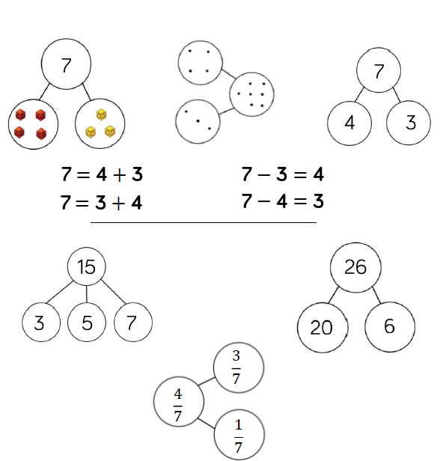 | This part-whole model supports children in their understanding of aggregation and partitioning.  When the parts are complete and the whole is empty, children use aggregation to add the parts together to find the total.  When the whole is complete and at least one if the parts is empty, children use partitioning (a form of subtraction) to find the missing part.  Part-whole models can be used to partition a number into two or more parts, or to help children partition a number into tens and ones or other place value columns.  In KS2, children can apply their understanding of the part-whole model to add and subtract fractions, decimals and percentages.
Bar Model (Singular)  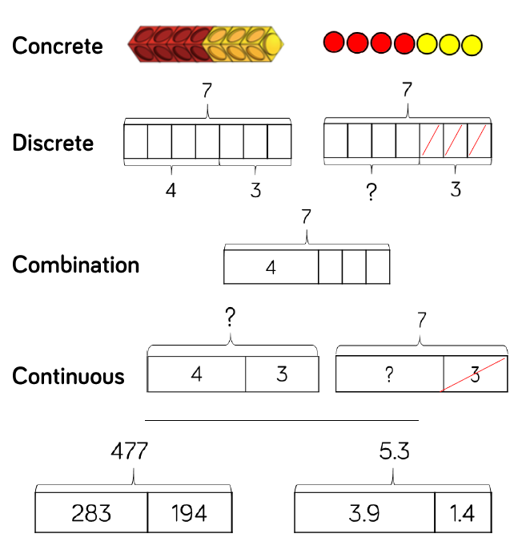 | This single bar model is another type of a part-whole model that can support children in representing calculations to help them unpick the structure.  Cubes and counters can be used in a line as a concrete representation of the bar model.  Discrete bar models are a good starting point with smaller numbers. Each box represents a whole.  The combination bar model can support children to calculate by counting on from the larger number. It is a good stepping stone towards the continuous bar model.  Continuous bar models are useful for a range of values. Each rectangle represents a number. The question mark indicates the value to be found.  In KS2, children can use bar models to represent larger number, decimals and fractions.
Bar Model (Multiple)  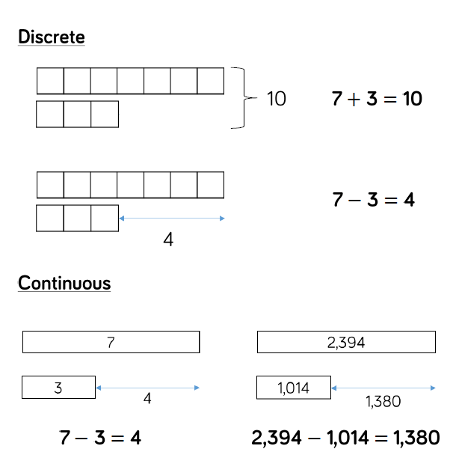 | The multiple bar model is a good wat to compare quantities whilst still unpicking the structure.  Two or more bars can be drawn, with a bracket labelling the whole positioned on the right hand sode of the bars. Smaller numbers can be represented with a discrete bar model whilst continuous bar models are more effective for larger numbers.  Multiple bar models can also be used to represent the difference in subtraction. An arrow can be used to model the difference.  When working with smaller numbers, children can use cubes and a discrete model to find the difference. This supports children to see how counting on can help when finding the difference.
Number Shapes  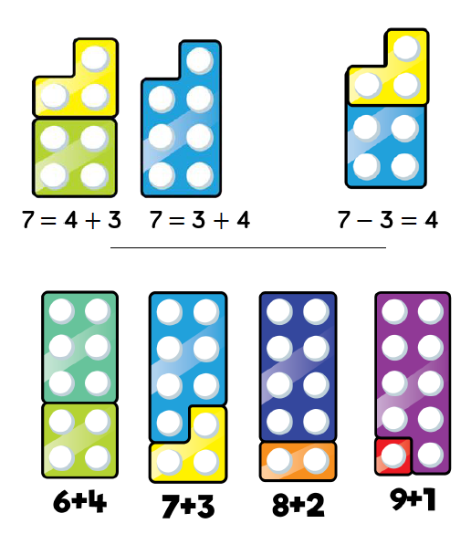 | Number shapes can be useful to support children to subitise numbers as well as explore aggregation, partitioning and number bonds.  When adding numbers, children can see how the parts come together making a whole. As children use number shapes more often, they can start to subitise the total due to their familiarity with the shape of each number.  When subtracting numbers, children can start with the whole and then place on of the parts on top of the whole to see what part is missing. Again, children will start to be able to subitise the part that is missing due to their familiarity with the shapes.  Children can also work systematically to find number bonds. As they increase one number by 1, they can see that the other number decreases by 1 to find all the possible number bonds for as number.
Cubes  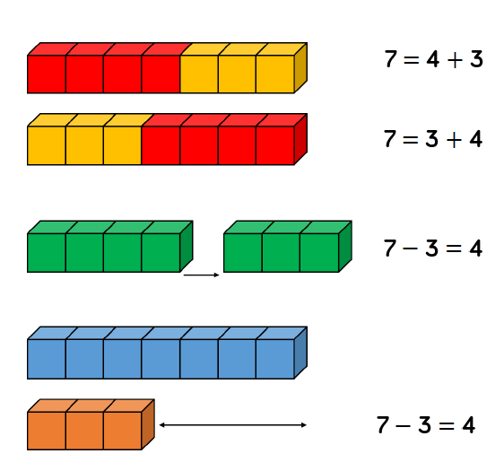 | Cubes can be useful to support children with the addition and subtraction of one-digit numbers.  When adding numbers, children can see how the parts come together to make a whole. Children could use two different colours of cubes to represent the numbers before putting them together to create the whole.  When subtracting numbers, children can start with the whole and then remove the number of cubes that they are subtracting in order to find the answer. This model of subtraction is reduction or take away.  Cubes can also be useful to look at subtraction as difference. Here, both numbers are made and then lined up to find the difference between the numbers.  Cubes are useful when working with smaller numbers but are less efficient with larger numbers as they are difficult to subitise, and children may miscount.
Ten Frames (Within ten)  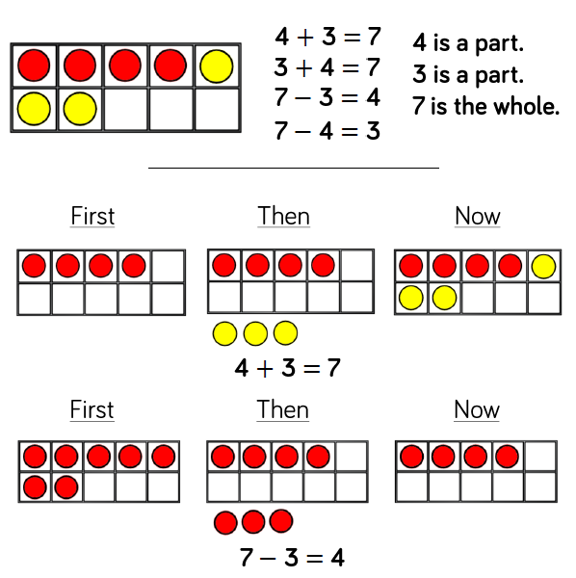 | When adding and subtracting within 10, the ten frame can support children to understand the different structures of addition and subtraction.  Using the language of parts and whole represented by objects on the ten frame introduces children to aggregation and partitioning.  Aggregation is a form of addition where parts are combined together to make a whole. Partitioning is a form of subtraction where the whole is split into parts. Using these structures, the ten frame can enable children to find all the number bonds for a number.  Children can also use ten frames to look at augmentation (increasing a number) and take-away (decreasing a number). This can be introduced through a first, then, now structure which shows the change in the number in the ‘then’ stage. This can be put into a story structure to help children understand the change e.g. First, there were 7 cars. Then, 3 cars left. Now, there are 4 cars.
Ten Frames (Within 20)  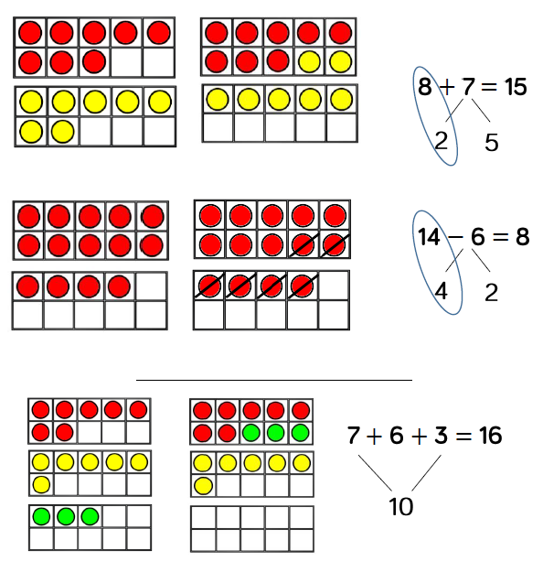 | When adding two single digits, children can make each number on separate ten frames before moving part of one number to make 10 on one of the ten frames. This supports children to see how they have partitioned one of the numbers to make 10, and makes links to effective mental methods of addition.  When subtracting a one-digit number from a two-digit number, firstly make the larger number on 2 ten frames. Remove the smaller number, thinking carefully about how you have partitioned the number to make 10, this supports mental methods of subtraction.  When adding three single-digit numbers, children can make each number on 3 separate 10 frames before considering which order to add numbers in. They may be able to find a number bon d to 10 which makes the calculation easier. Once again, the ten frames support the link to effective mental methods of addition as well as the importance of commutativity.
Bead Strings  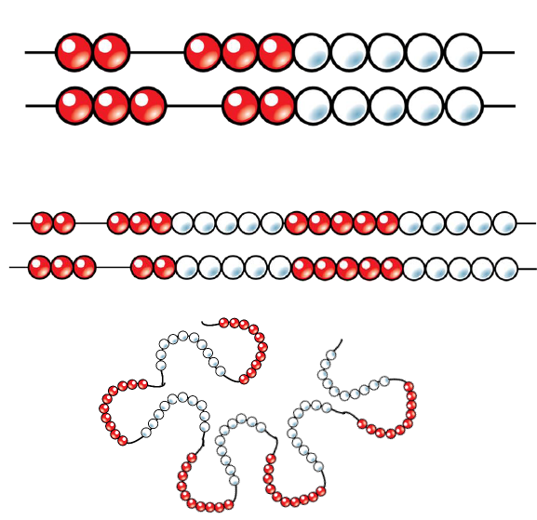 | Different sizes of bead strings can support children at different stages of addition and subtraction.  Bead strings to 10 are very effective at helping children investigate number bonds to 10. They can help children to systematically find all the number bonds to 10 by moving one bead at a time to see the different numbers they have partitioned the beads into e.g. 2 + 8 = 10, move one bead, 3 + 7 = 10.  Bead strings to 20 work in a similar way but they also groups the beads in fives. Children can apply their knowledge of number bonds to 10 and see the links to number bonds to 20.  Bead strings to 100 are grouped in tens and can support children in number bonds to 100 as well as helping when adding by making ten. Bead strings can show a link to adding to the next 10 on number lines which supports a mental method of addition.
Number Tracks  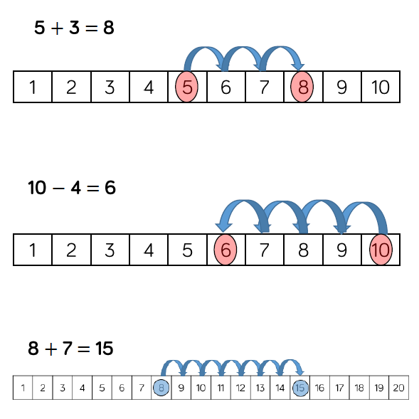 | Number tracks are useful to support children in the understanding of augmentation and reduction.  When adding, children count on to find the total of the numbers. On a number track, children can place a counter on the starting number and then count on to find the total.  When subtracting, children count back to find their answer. They start at the minuend and then take away the subtrahend to find the difference between the numbers.  Number tracks can work well alongside 10 frames and bead strings which can also model counting on or counting back.  Playing board games can help children to become familiar with the idea of counting on using a number track before they move on to number lines.
Number Lines (Labelled)  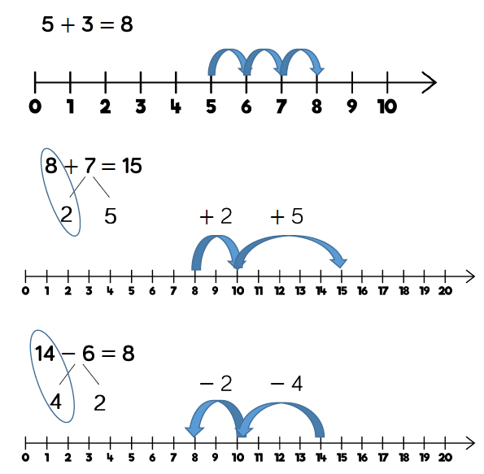 | Labelled number lines support children in their understanding of addition and subtraction as augmentation and reduction.  Children can start by counting on or backing ones, up or down the number line. This skill links directly to the use of the number track.  Progressing further, children can add numbers by jumping to the nearest ten and then jumping to the total. This links to the making ten method which can also be supported by 10 frames. The smaller number is partitioned to support children to make a number bond to 10 until then add on the remaining part.  Children can subtract numbers by firstly jumping to the nearest ten. Again, this can be supported by 10 frames so children can see how they partition the smaller number into the two separate jumps.
Number Lines (Blank)  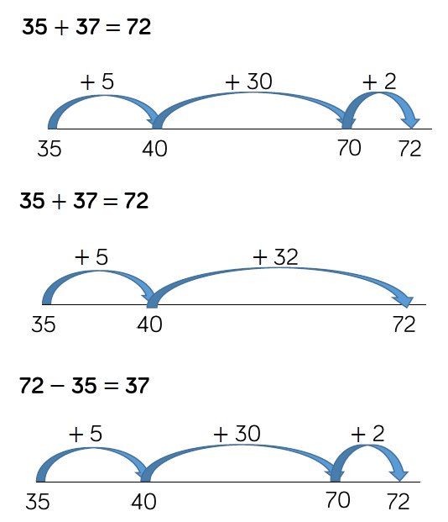 | Blank number lines provide children with a structure to add and subtract number in smaller parts.  Developing from labelled number lines, children can add by jumping to the nearest 10 and then adding the rest of the number either as a whole or by adding the tens and ones separately.  Children may also count back on a number line to subtract, again by jumping to the nearest 10 and then subtracting the rest of the number.  Blank number lines can also be used effectively to help children subtract by finding the difference between numbers. This can be done by starting with the smaller number and then counting onto the larger number. They then add up the parts they have counted on to find the difference between the numbers.
Straws  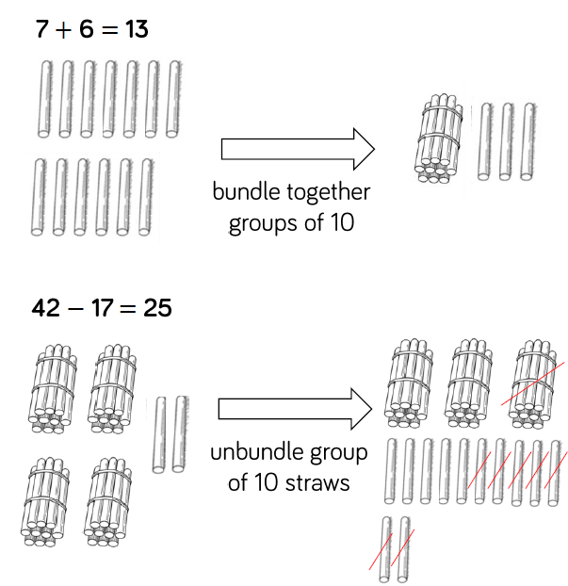 | Straws are an effective way to support children in their understanding of exchange when adding a subtracting 2-digit numbers.  Children can be introduced to the idea of bundling groups of 10 when adding smaller numbers and when representing 2-digit numbers. Use elastic bands or other ties to make bundles of 10 straws.  When adding numbers, children bundle a group of 10 straws to represent the exchange from 10 ones to 1 ten. They then add the individual straws (ones) and bundles of straws bracket (tens) to find the total.  When subtracting numbers, children unbundle a group of 10 straws to represent the exchange from 1 ten to 10 ones.  Straws provide a good stepping stone to adding and subtracting with Base 10 equipment.
Base 10 (Addition)  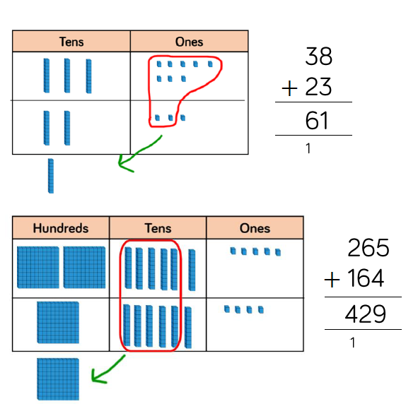 | Using Base 10 is an effective way to support children's understanding of column addition. It is important that children can write out their calculations alongside using or drawing Base 10 so they can see the clear links between the written method and the model.  Children should first add without an exchange before moving onto addition with exchange. The representation becomes less efficient with larger numbers due to the size of Base 10. In this case, place value counters may be the better model to use.  When adding, always start with the smallest place value column. Here are some questions to support children.  How many ones are there altogether?  Can we make an exchange? (Yes or No)  How many do we exchange? (10 ones for 1 ten, show exchanged 10 in the tens column by writing 1 in column)  How many ones do we have left? (Write in ones column)  Repeat for each column.
Base 10 (Subtraction)  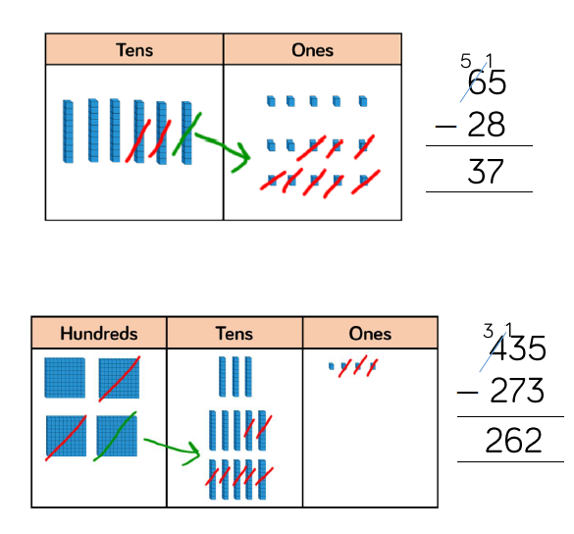 | Using Base 10 is an effective way to support children's understanding of column subtraction. It is important that children can write out their calculations alongside using or drawing Base 10 so they can see the clear links between the written method and the model.  Children should first subtract without an exchange before moving on to subtraction with exchange. When building the model, children should just make the minuend using Base 10, they then subtract the subtrahend. Highlight this difference to addition to avoid errors by making both numbers. Children start with the smallest place value column. When there are not enough ones/tens/hundreds to subtract in a column, children need to move to the column to the left and exchange e.g. exchange 1 ten for 10 ones. They can then subtract efficiently.  This model is efficient with up to 4- digit numbers. Place value counters are more efficient with larger numbers and decimals.
Place Value Counters (Addition)  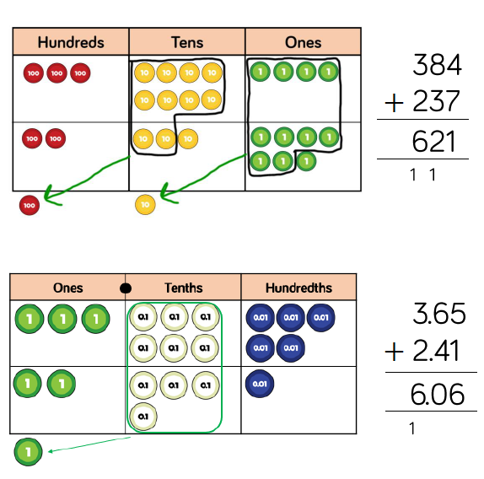 | Using place value counters is an effective way to support children's understanding of column addition. It is important that children write out their calculations alongside using or drawing counters so they can see the clear links between the written method and the model.  Children should first add without an exchange before moving on to addition with exchange. Different place value counters can be used to represent larger numbers or decimals. If you don't have place value counters, use normal counters on a place value grid to enable children to experience the exchange between columns.  When adding money, children can also use coins to support their understanding. It is important that children consider how the coins linked the written calculation especially when adding decimal amounts.
Place Value Counters (Subtraction)  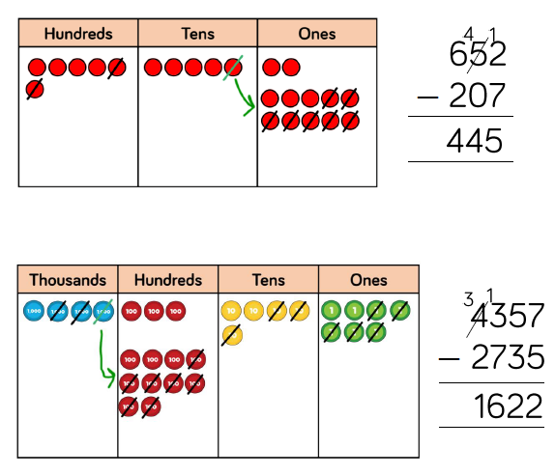 | Using place value counters is an effective way to support children’s understanding of column subtraction. It is important that children write out their calculations alongside using or drawing counters so they can see the clear links between the written method and the model.  Children should first subtract without an exchange before moving on to subtraction with exchange. If you don't have place value counters, use normal counters on a place value grid to enable children to experience the exchange between columns.  When building the model, children should just make the minuend using counters, they then subtract the subtrahend. children start with the smallest place value column. When there are not enough ones/tens/hundreds to subtract in a column, children need to move to the column to the left and exchange e.g. exchange 1 ten for 10 ones. They can then subtract efficiently.
Progression in Manipulatives for Multiplication and Division
Manipulatives/Representations | Benefits and Progression
Bar Model  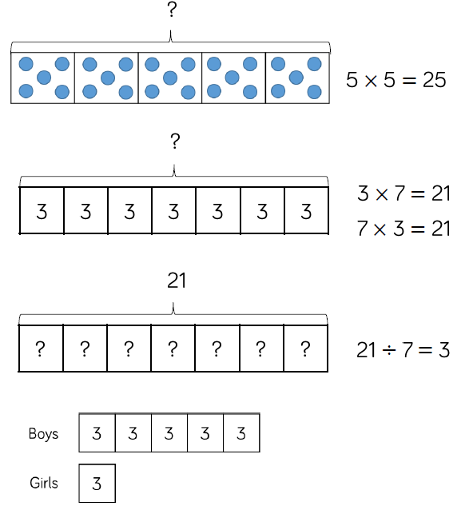 | Children can use the single bar model to represent multiplication as repeated addition. They could use counters, cubes or dots within the bar model to support calculation before moving on to placing digits into the bar model to represent the multiplication.  Division can be represented by showing the total of the bar model and then dividing the bar model into equal groups.  It is important when solving word problems that the bar model represents the problem.  Sometimes, children may look at scaling problems. In this case, more than one bar model is useful to represent this type of problem, e.g. There are three girls in a group. There are five times more boys than girls. How many boys are there?  The multiple bar model provides an opportunity to compare the groups.
Number Shapes  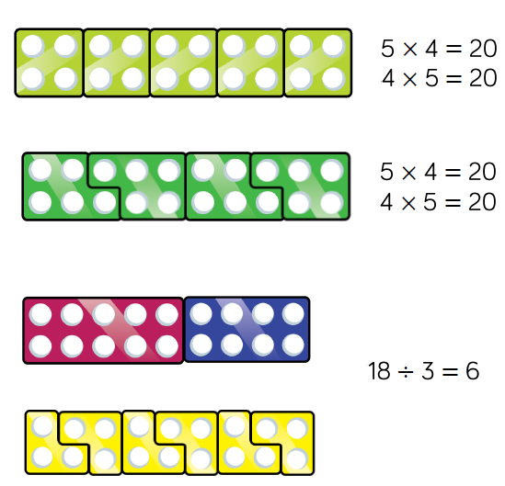 | Number shapes support children's understanding of multiplication as repeated addition.  Children can build multiplications in a row using the number shapes. When using odd numbers, encourage children to interlock the shapes so there are no gaps in the row. They can then use the tens number shapes along with other necessary shapes over the top of the row to check the total. Using the number shapes in multiplication can support children in discovering patterns of multiplication e.g. odd x odd = even, odd x even = odd, even x even = even.  When dividing, number shapes support children's understanding of division as grouping. Children make the number they are dividing and then place the number shape they are dividing by over the top of the number to find how many groups of the number there are altogether e.g. There are 6 groups of 3 in 18.
Bead Strings  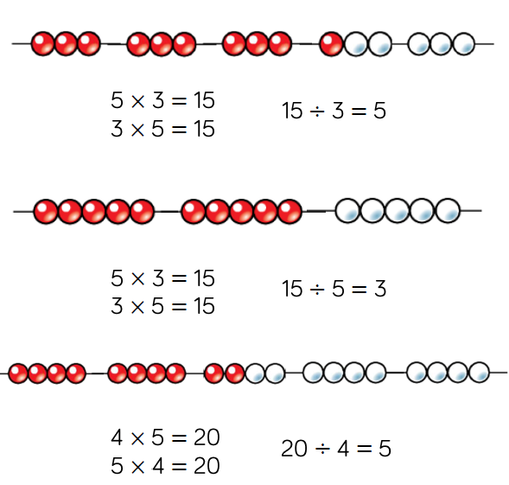 | Beads strings to 100 can support children in their understanding of multiplication as repeated addition. Children can build the multiplication using the beads. The colour of beads supports children in seeing how many groups of 10 they have, to calculate the total more efficiently. Encourage children to count in multiples as they build the number e.g. 4, 8, 12, 16, 20.  Children can also use the bead string to count forwards and backwards in multiples, moving the beads as they count.  When dividing, children build the number they are dividing and then group the beads into the number they are dividing by e.g. 20 divided by 4 - Make 20 and then group the beads into groups of four. Count how many groups you have made to find the answer.
Number Tracks  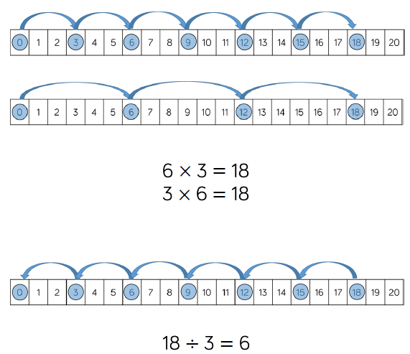 | Number tracks are useful to support children to count in multiples, forwards and backwards. Moving counters or cubes along the number track can support children to keep track of their counting. Translucent counters help children to see the number they have landed on whilst counting.  When multiplying, children place their counter on 0 to start and then count on to find the product of the numbers.  When dividing, children place their counter on the number they are dividing and count back in jumps of the number they are dividing by until they reach 0. Children record how many jumps they have made to find the answer to the division.  Number tracks can be useful with smaller multiples but when reaching larger numbers they can become less efficient.
Number Lines (labelled)  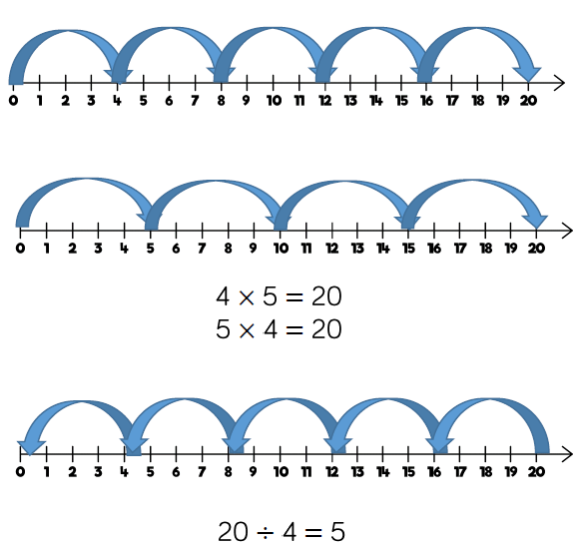 | Labelled number lines are useful to support children to counting multiples, forwards and backwards as well as calculating single-digit multiplications.  When multiplying, children start at 0 and then count on to find the product of the numbers.  When dividing, they start at the number they are dividing and then count back in jumps of the number they are dividing by until they reach zero. Children record how many jumps they have made to find the answer to the division.  Labelled number lines can be useful with smaller multiples however they become inefficient as numbers become larger due to the required size of the number line.
Number Lines (Blank)  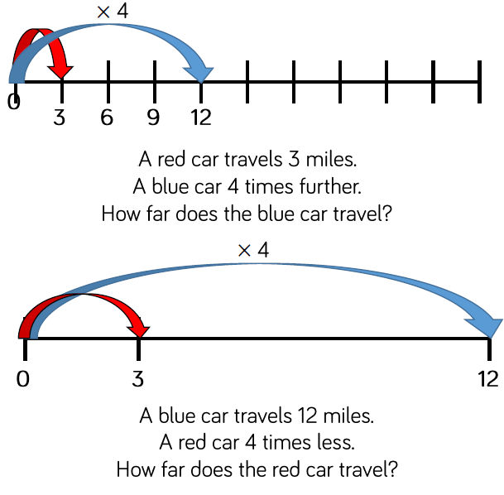 | Children can use blank number lines to represent scaling as multiplication or division.  Blank number lines with intervals can support children to represent scaling accurately. Children can label intervals with multiples to calculate scaling problems.  Blank number lines without intervals can also be used for children to represent scaling.
Base 10 (Multiplication)  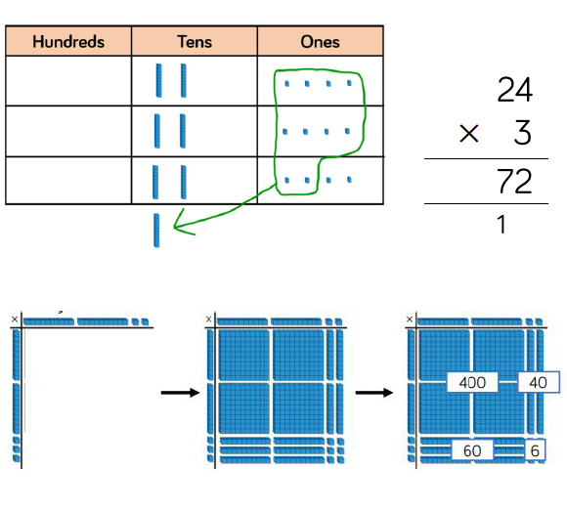 | Using Base 10 is an effective way to support children's understanding of column multiplication. It is important that children write out their calculation alongside the equipment so they can see how the concrete unwritten representations match.  As numbers become larger in multiplication or the amounts of groups becomes higher, Base 10 becomes less efficient due to the amount of equipment and number of exchanges needed.  Base 10 also supports the area model of multiplication well. Children use the equipment to build the number in a rectangular shape which they can then find the area of by calculating the total value of the pieces. This area model can be linked to the grid method or the formal column method of multiplying 2-digits by 2-digits.
Base 10 (Division)  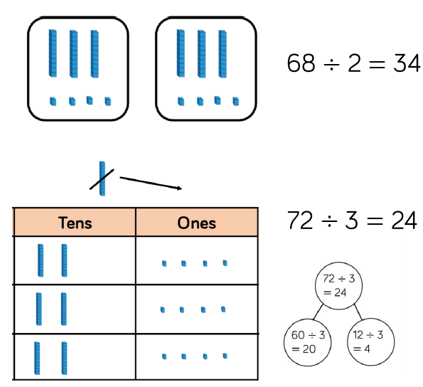 | Using Base 10 is an effective way to support children's understanding of division.  When numbers become larger it can be an effective way to move children from representing numbers as ones towards representing them as tens and ones in order to divide. Children can then share the Base 10 between different groups e.g. by drawing circles or by rows on a place value grid.  When they are sharing, children start with the larger place value and work from left to right. If there are any left in a column, they exchange e.g. one ten for ten ones. When recording, encourage children to use the part-whole model so they can consider how the number has been partitioned in order to divide. This will support them with mental methods.
Place Value Counters (Multiplication)  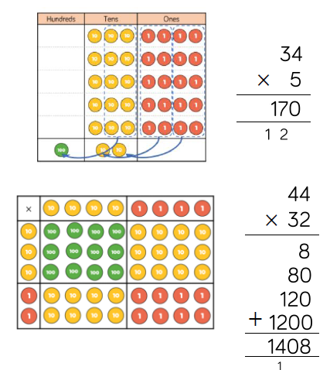 | Using place value counters is an effective way to support children's understanding of column multiplication. It is important that children write out their calculation alongside the equipment so they can see how the concrete and written match.  As numbers become larger in multiplication or the amounts of groups becomes higher, Base 10 becomes less efficient due to the amount of equipment and number of exchanges needed. The counters should be used to support the understanding of the written method rather than support the arithmetic.  Place value counters also support the area model of multiplication well. Children can see how to multiply 2-digit numbers by 2-digit numbers.
Place Value Counters (Division)  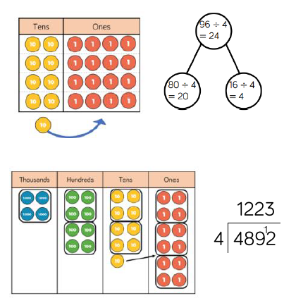 | Using place value counters is an effective way to support children's understanding of division.  When working with smaller numbers, children can use place value counters to share between groups. They start by sharing the larger place value column and work from left to right. If there are any counters left over once they have been shared, they exchanged the counter e.g. exchange 1 ten for 10 ones. This method can be linked to the part-whole model to support children to show their thinking.  Place value counters also support children's understanding of short division by grouping the counters rather than sharing them. Children work from left to right through the place value columns and group the counters in the number they are dividing by. If there are any counters left over after they have been grouped, they exchanged the counter e.g. exchange one hundred for ten tens.
Progression and benefits adapted from White Rose Maths.

