School Uniform

Our school uniform supplier is Nationwide School Uniforms and uniform can be ordered and paid for on-line; please note we do not hold any stock in school. The link to the website is below, you will then need to search for Spalding Parish to access the uniform.

www.nationwideschooluniforms.co.uk

If you order uniform by the third Monday of the month the uniform will be delivered to school in the last week of the month, free of charge. If you wish to have the uniform delivered to your home address quicker you can pay postage and it will be delivered soon after you have ordered it, or you can pick it up from the suppliers’ shop in Spilsby.

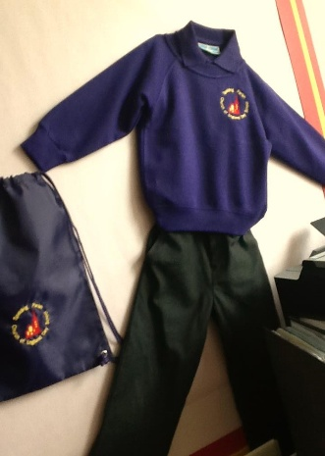
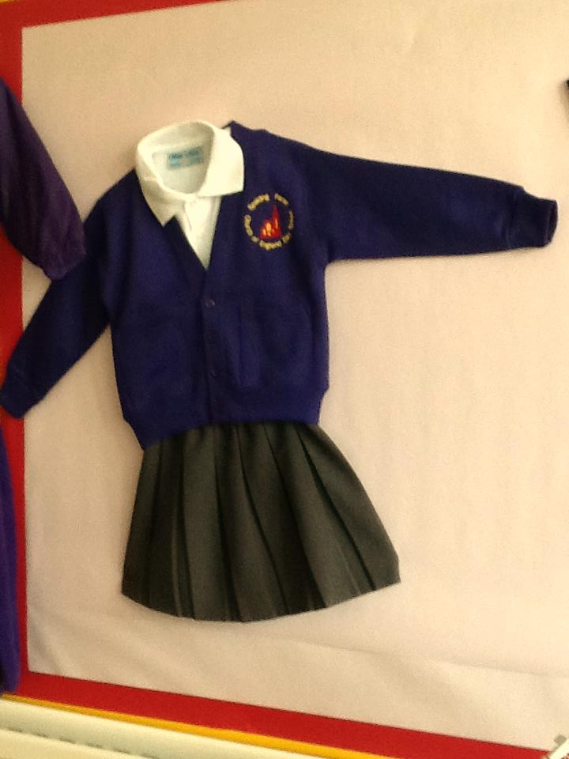
Boys and Girls
Purple Sweatshirt or Cardigan
Purple or White Polo Shirt
Grey Trousers, Dress or Skirt
Purple, Red or Yellow Gingham Summer Dress
Plain Grey, Black or White Socks or Tights
Flat Black Shoes - No trainers or heels
No nail varnish
Jewellery – only earring studs or small objects of religious significance
(these must be removed on PE days)

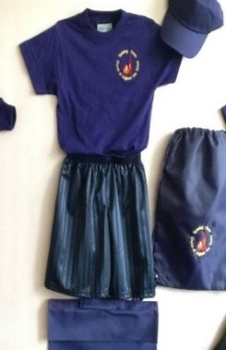
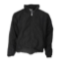

PE KIT
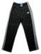
Navy Blue/Black Shorts or Joggers
Purple T-Shirt
School Jumper
Trainers
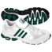
No earrings or jewellery to be worn on PE days

Please support children to be independent when getting changed by
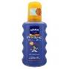
ensuring they can recognise their name and items of clothing.

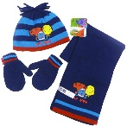
Sunhat and suncream in the summer

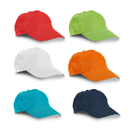
Hat, gloves and scarf in winter

Please remember to name all items!

