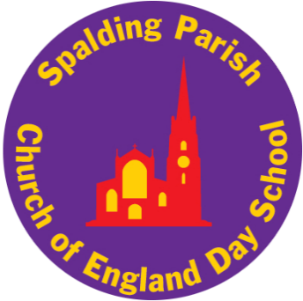

Spalding Parish Church of England Day School

WELCOME TO
SPALDING PARISH
CHURCH OF ENGLAND
DAY SCHOOL

2025-2026

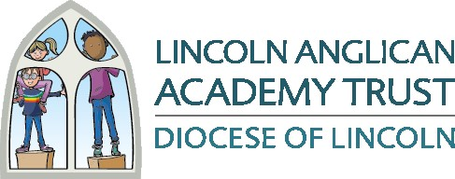

Contents
- Starting School Checklist
- School Day
- School Uniform and PE Kit
- Children’s Absences
- School Terms and Holidays
- Snacks and Water
- Packed Lunches
- Hot School Meals
- Ordering Hot School Meals
- Free School Meal Application and Guidance
- Medicines
- Sun Safety
- School Letters
- School Milk
- Treats for Children
- Raising a Concern
- Lincoln Anglican Academy Trust Privacy Notice
- Expected Behaviour of Parents/Carers to our School
- Parent/Carers Code of Conduct

Starting School Checklist

- Complete Pupil Information Booklet and return to school. Please speak to the school if you need any support with this.

- Bring your child’s full Birth Certificate and Passport if they have one to the School Office as soon as possible and before you child starts with us.

- In readiness for your child starting school, please name all items of clothing and make sure your child knows where to find their name on each item.

Timings of the School Day

Start of the Day
EYFS and KS1 Children: 8.50am
KS2 Children: 8.45am
Doors open 10 minutes before so that your child can be
ready for registration at that time.

End of the School Day
EYFS and KS1 Children: 3.10pm
KS2 Children: 3.20pm

School Uniform

Our school uniform supplier is Nationwide School Uniforms and uniform can be ordered and paid for on-line; please note we do not hold any stock in school. The link to the website is below, you will then need to search for Spalding Parish to access the uniform.

http://www.nationwideschooluniforms.co.uk/index.php?route=product/search&keyword=spa

If you order uniform by the third Monday of the month the uniform will be delivered to school in the last week of the month, free of charge. If you wish to have the uniform delivered to your home address quicker you can pay postage and it will be delivered soon after you have ordered it, or you can pick it up from the suppliers’ shop in Spilsby.
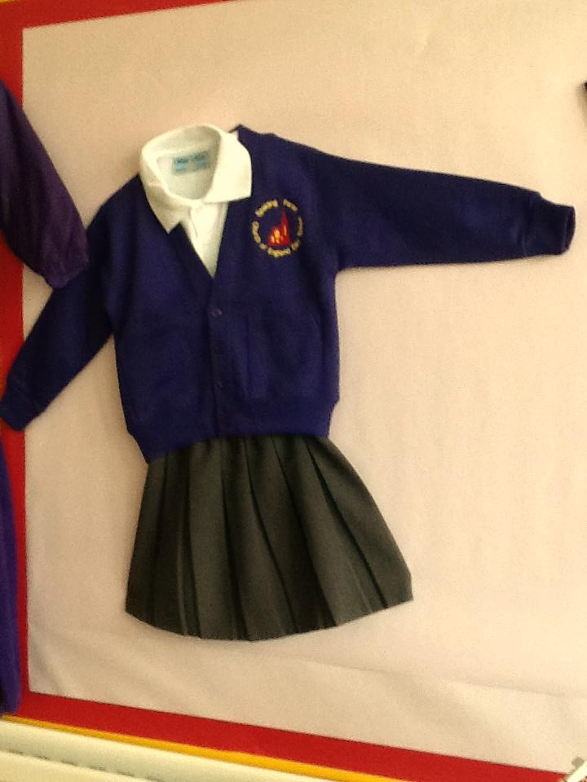
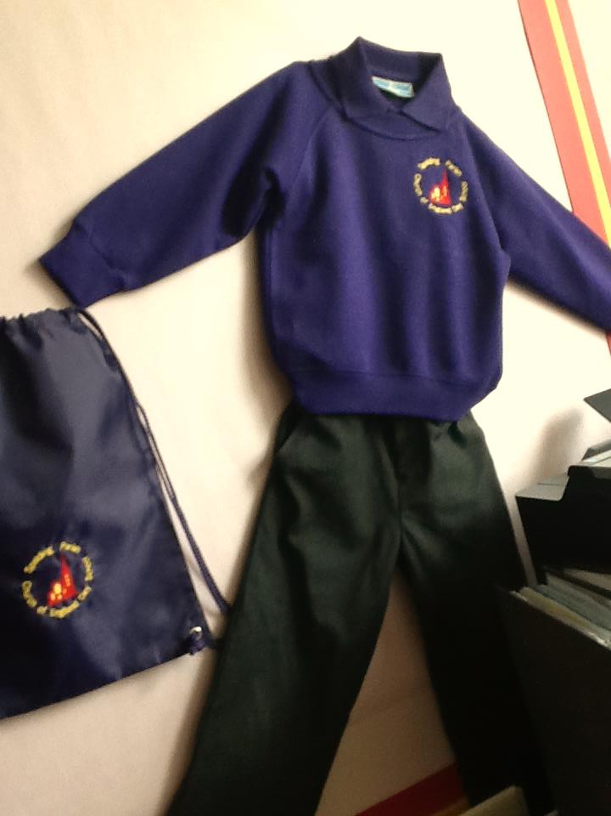
Boys and Girls
Purple Sweatshirt or Cardigan
Purple or White Polo Shirt
Grey Trousers, Dress or Skirt
Purple, Red or Yellow Gingham Summer Dress
Plain Grey, Black or White Socks or Tights
Flat Black Shoes - No trainers or heels
No nail varnish
Jewellery – only earring studs or small objects of religious significance
(these must be removed on PE days)

All items to be clearly named

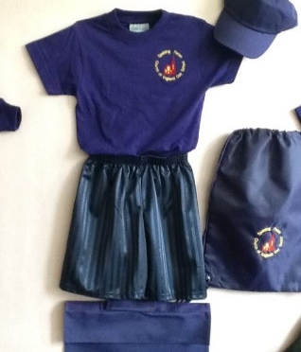
PE KIT

Navy Blue/Black Shorts

Purple T-Shirt
Tracksuit (dark colour/plain)
Plimsolls or Trainers

No earrings or jewellery to be worn on PE days



Please support children to be independent when getting changed by
ensuring they can recognise their name and items of clothing.


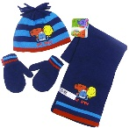
Sunhat and suncream in the summer

Hat, gloves and scarf in winter

Please remember to name all items!

Children’s Absences

Illness
If your child is absent from school you must contact the School Office by 9.30am on each day of absence giving the reason. This is for safeguarding reasons; if your child isn’t in school for any reason we need to know that they are safe.

Our email address is attendance@spaldingparish.laat.co.uk or you can call 01775 722333 where there is an answerphone service available.

NOTE: Sickness and Diarrhoea
If your child has been vomiting or had diarrhoea, we ask that 48 hours should elapse from the last episode of sickness or diarrhoea before returning to school in line with NHS guidance.

Where a pupil is absent due to sickness and is genuinely unable to attend school, then the school, after being informed, may authorise a child's absence.

We do encourage and appreciate honesty and we may contact parents to discuss if we have reason to believe a child is on holiday and not unwell as advised.

It is important to keep the school office informed every day if your child is going to be absent at the start of the day. Schools will monitor and engage with parents as soon as a pattern of absence becomes apparent. If your child is frequently absent due to illness the school may request permission to contact your GP for confirmation that they are too ill to attend school. Any absence where no reason has been provided will automatically be recorded as unauthorised.

The decision to authorise an absence can only be taken by the Head Teacher, or the person designated by the Head Teacher to take this decision (The Education (Pupil Registration) Regulations 1995 as amended). If the school decides that the reason given is not valid and your child does not attend school, the absence will be unauthorised.

Where a child has high levels of unauthorised absence further legal action by the Local Authority could be considered. This letter should be considered as a warning that school may request a Penalty Notice be issued if the unauthorised absence % meets the criteria as set out under Lincolnshire County Council Penalty Notice Code of Conduct and in line with DfE guidance.

Medical Appointments
Where possible, we encourage such appointments take place out of school time so not to disrupt your child’s education; please arrange such appointments outside school hours where possible.

Whilst we appreciate that medical appointments are unavoidable and the times are not always flexible, such absences usually only take up part of a day so children should come to school before and/or after the appointment.

School should be informed of such absences in advance - we also require confirmation of appointment i.e. copy of appointment letter/text message reminder/email.

Holidays/Other Absences or Appointments
Holidays and some other absences cannot be authorised during term time. Leave of Absences can only be granted in exceptional circumstances. Should you need to take your child out of school, please make an appointment with the Head Teacher or a member of the SLT at least 14 days prior to the absence so that we can discuss the reasons for needing to take your child out of school during term time. Only then will the decision be made as to whether the absence will be authorised within the framework and guidance of the law.

Only the school, in the context of the law can authorise an absence, a note or explanation from parents/carers does not guarantee authorisation. If a Class Teacher does not accept the explanation offered for absence as a valid reason then the matter must be referred to the Head Teacher. Therefore, if we are aware that children have been on holiday but we are told otherwise, this absence will be unauthorised.

If the permission to take leave of absence is not granted and the pupil still goes on leave, the absence will be unauthorised. If a child has unauthorised absences recorded (through non-attendance or lateness), it could lead to the issuing of a Penalty Notice by the Local Authority.

Penalty Notices are a tool to combat poor attendance and/or high unauthorised absence due to families taking holidays in term time, lateness or persistent absence. Section 444 of the Education Act 1996 enables Local Authorities to issue a Fixed Penalty Notice where a parent/carer has failed to ensure the regular school attendance of their child at the school that they are a registered pupil at or other education provision provided for them.

Please see the school’s Attendance Policy for further information.

School Terms & Holidays for

Academic Year 2025/2026

Term 1 Staff Training Day Tuesday 2nd and Wednesday 3rd September 2025

School Opens: Thursday 4th September 2025

School Closes: Thursday 23rd October 2025 at 3:10pm FS2/KS1

and 3:20pm KS2

Term 2
School Opens: Monday 3rd November 2025
School Closes: Friday 19th December 2025 at 3:10pm FS2/KS1
and 3:20pm KS2

Term 3 Staff Training Day Monday 5th January 2026
School Opens: Tuesday 6th January 2026
School Closes: Friday 13th February 2026 at 3:10pm FS2/KS1
and 3:20pm KS2

Term 4
School Opens: Monday 23rd February 2026
School Closes: Thursday 2nd April 2026 at 3:10pm FS2/KS1 and 3:20pm KS2

Term 5 Staff Training Day: Monday 20th April 2026
School Opens: Tuesday 21st April 2026
School Closes: Friday 22nd May 2026 at 3:10pm FS2/KS1 and 3:20pm KS2
Bank Holiday: Monday 4th May

Term 6

School Opens: Monday 1st June 2026

School Closes: Wednesday 23rd July 2026 at 3:10pm FS2/KS1

and 3:20pm KS2

Snack – EYFS, Year 1 and Year 2 children only

As a school we continue to participate in the Government’s Fruit and Vegetable Scheme entitling every child in EYFS and Key Stage 1 to receive a free piece of fruit or vegetable each day. This reinforces our commitment to healthy eating and replaces morning snacks for all children in these year groups. As such, you do not need to send your child with a snack each day as this will be provided as part of this scheme.





Children in Key Stage 2 can bring a snack into school but again we would encourage a piece of fruit, a small snack or cereal bar, or something similar. Children should not be bringing bars of chocolate, sweets or bags of crisps for their snacks. If we could please ask for parent/carers’ support with this that would be very much appreciated.

Please note: we are a nut-free school. Please don’t send your child with any snacks/food that may contain nuts.

Water


It has been proven that drinking plenty of water increases children’s mental alertness and so helps them to learn more effectively. Fresh, chilled and filtered, mains-supplied water is freely available in school for the children.

Each child should have their own named plastic water bottle which they can refill from the water coolers as necessary and which is kept easily accessible at all times.

Please be aware that the same benefits do not apply to squash or even flavoured waters, with many of these including a high % of sugar and as such children should only be drinking water during their time in school.

Packed Lunches

You may choose to provide your child with a healthy packed lunch however all Early Years children currently receive a free school meal through the Universal Infant Free School Meals scheme. This currently includes children in EYFS, Year 1 and Year 2. See section on Hot School Meals.

We would encourage parents/carers to ensure there is a healthy balance in packed lunches given the important part that food plays in children being ready to learn. As you will no doubt be aware at school we have to abide by the Food Standards guidance and as such our recommendation for a healthy packed lunch would be as follows:

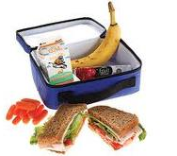
- Sandwich (can be replaced with another savoury item e.g. a wrap, but
NOT to be replaced with a sweet alternative e.g. a donut or croissant)
- Savoury snack such as crackers
- Fruit
- Sweet snack such as a cereal/biscuit bar

Nuts - VERY IMPORTANT: SPCEDS is a ‘nut-free’ zone
Please note that we cannot allow nuts in school either as a snack, in snack bars or as peanut butter in sandwiches due to the risk of anaphylaxis. This also includes any food item where nuts may be present in chocolate spreads and fillings such as Nutella. Even the dust from peanuts can be fatal and it is imperative that all adhere to this very important regulation.

For safety of all we are a nut-free school which means all nut-based products are prohibited from the school premises.

Please do not send your child into school with any nut-based product for packed lunch or for a snack – this includes all products that may contain traces of nuts.


Potential allergens could include the following:
- Spreads, e.g. chocolate spread
- Cereal bars
- Some types of biscuit containing nuts
- Condiments, e.g. satay sauce
- Cakes containing nuts
- Snack pots containing nuts Examples of items NOT allowed in school

It is important that you check the labelling of food products before sending your child in to school with them – it is not always apparent that products contain nuts or traces of nuts.

We also ask that, if your child consumes any nut-based product before school, they wash their hands thoroughly and rinse their mouth before entering the school grounds. We understand that these measures may seem extreme; however, we want to ensure the health and safety of the whole school community, with the allergy so severe in some cases that even the slightest of contact with nuts could cause a severe and potentially life-threatening reaction.

Due to the severity of the allergy, if any pupil is found with a nut-based product the school will confiscate it immediately and contact will be made with parents/carers. Thank you for your support with this matter. If you do have any questions or concerns, please do not hesitate to contact the school office.

Class teachers and lunchtime supervisors do keep a very close eye on lunches in school and this will continue to be the case. With health, including a healthy diet, a key focus of the PHSE curriculum we will continue to encourage healthy packed lunches, snacks and drinks across school given the positive benefits of this. Your support with this is very much appreciated.

Hot School Meals

We are fortunate to have a kitchen on the school site – this is currently run by Caterlink. As a result, nutritious well-balanced meals are freshly cooked each day on site. Caterlink closely working with the Lincolnshire Food in Schools team to ensure hot meals produced for the children are healthy and meet statutory guidance. As such children have a daily choice of:

- A hot meal
- A vegetarian option
- A jacket potato with filling
- A school-made packed lunch

The meals provided by the Caterlink team are proving very popular and I know the ladies in the kitchen have been keenly developing this provision, providing meals that the children enjoy but that are also healthy and nutritionally sound.

As part of your child starting school, we would encourage all of you to book the freshly prepared hot meals for your child for their school lunch. Given the Government initiative of Universal Infant Free School Meals, these meals are free to all pupils in EYFS, Year 1 and Year 2 and as such our preferred option for our Foundation Stage and Key Stage 1 pupils, ensuring that pupils receive a healthy meal at lunchtimes in line with statutory guidance.

As a school we would appreciate your support in ensuring pupils are receiving a healthy daily diet during their time in school and would like to thank you in anticipation of this. If you do have any questions or queries, please do not hesitate to get in touch with myself or a member of the Senior Leadership Team.

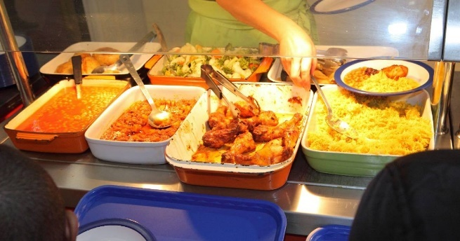

Ordering Hot Meals

Every child in EYFS, Year 1 and Year 2 is entitled to a Free School Meal provided by the Government (Universal Infant Free School Meals). We recommend your child takes up this free offer. Lunches are ordered through MCAS, our payments and communication platform.

If you do not order, or do not want your child to have a free hot lunch, you must send a packed lunch for your child to have.

For new children in all Year Groups, once your child has started with us you should be able to register on the My Child at School app. This is where you can order your lunches.

The hot meal menu is put onto MCAS termly; it is usually put on the website at the end of term ready for you to order before the start of the next term.

Meals must be ordered a week in advance of needing them (and by 11.59pm on the Tuesday evening) for example, order by 11.59pm on Tuesday 1st of the month for meals that are required for week commencing Monday 7th of the month and after. As the menu is put on MCAS for the whole term, you can order as many meals as you want.

Should you experience problems registering on MCAS and ordering meals or have any questions about the Universal Infant Free School Meals, the office staff will be available to assist you.

All meals and school trips have to be ordered/paid for through MCAS so we recommend you register on there as soon as you have been registered.

NOTE: Your child will still need to bring a drink with them to drink during the day.



Free School Application and Guidance

All Early Years and Key Stage 1 children are currently entitled to receive a free school meal through the Universal Infant Free School Meals scheme. This currently includes children in Foundation Stage, Year 1 and Year 2. However, if a family are in receipt of certain benefits, we strongly recommend parents/carers apply for Free School Meals now so that once their child becomes of the age where UIFSM do not apply, the child can continue to receive free school meals.

Are you in receipt of any of the benefits below?
Free school meals are available to pupils in receipt of, or whose parents are in receipt of, one or more of the following benefits:

- Universal Credit (provided you have an annual net earned income of no more than £7,400, as assessed by earnings from up to three of your most recent assessment periods)

- Income Support • Income-based Jobseeker’s Allowance • Income-related Employment and Support Allowance

- Support under Part VI of the Immigration and Asylum Act 1999

- The guarantee element of Pension Credit

- Child Tax Credit (provided you’re not also entitled to Working Tax Credit and have an annual gross income of no more than £16,190)

- Working Tax Credit run-on – paid for four weeks after you stop qualifying for Working Tax Credit

If so, your child may be eligible for Free School Meals. They will also qualify for Pupil Premium Funding that the school then receives to support educational provision.

Free school meals offer a healthy, wide selection of options for your child at lunchtime and can save families approximately £460 per year.

If you think you are eligible, we would strongly recommend you make an application, particularly given the fact there is no confirmation of how long the Universal Infant Free School Meal scheme will be available for. If your application is successful this means school would receive additional funding that could be used to support your child’s education during their time in school.

Please see the following guidance below on how to apply. If you are unable to access the online portal below please contact school or the Customer Service Centre for assistance.

FSM Application Guidance for Parents/Carers

Create an account using your email address on the online Parent Portal: Synergy - Enquiry

Step 1
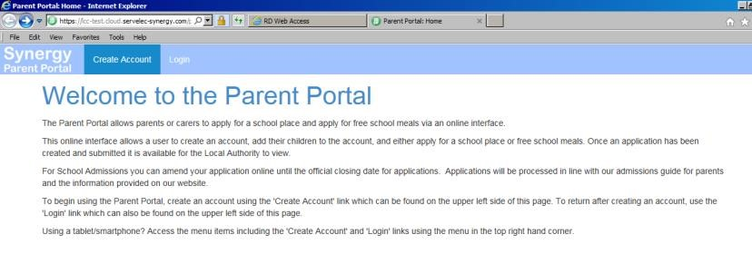

Step 2
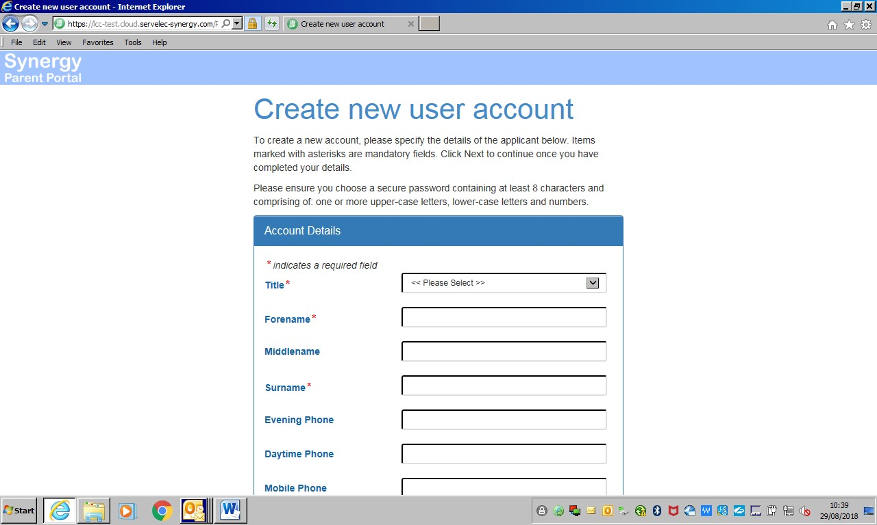

Step 3
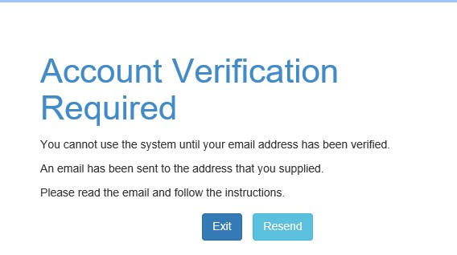
Step 4

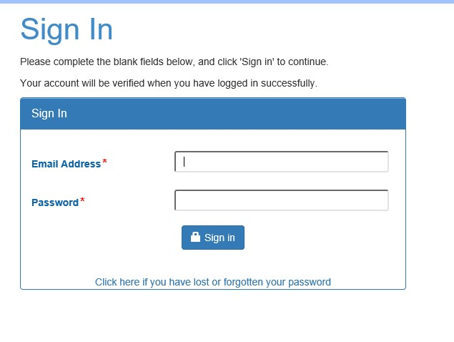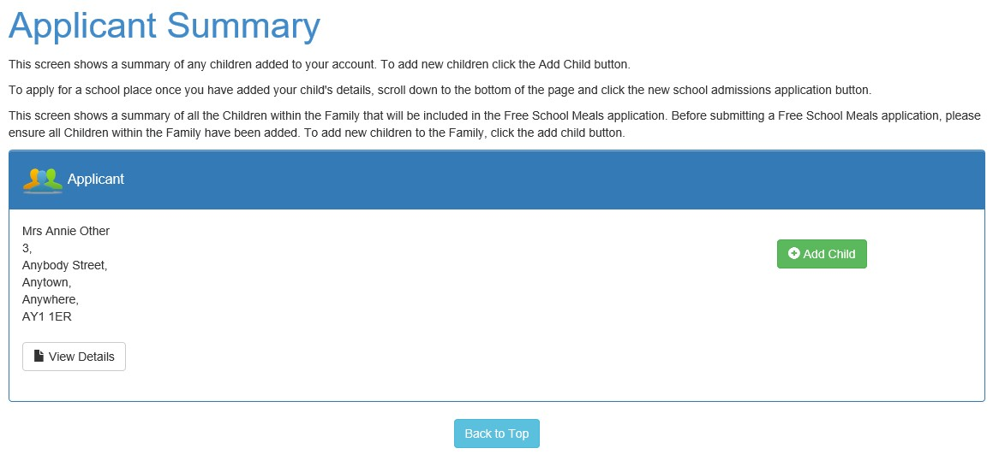

Step 5 An email will be sent advising if 'eligible' or 'not eligible' for free school meals.

Important Information – If you receive a 'not eligible' letter, please check the date of birth and the National Insurance Number for the parent/carer has been entered correctly on the online Parent Portal.

Telephone enquiries – Customer Services Centre Tel: (01522) 782030

Medicines


Medication prescribed by a Doctor can be administered by designated staff on completion a consent form which can be collected and returned to the School Office.

Non-prescription medicine is NOT ALLOWED in school however, following recent advice from a local GP surgery, we are able to administer certain non-prescribed medicines such as paracetamol and ibuprofen based products (e.g. Calpol). A request in writing is still required, via the relevant form, stating required dose and timings and all medication must be very clearly labelled with the child’s name.

Sun Safety

When we see the arrival of the sunshine and warmer weather, please remember the following:

- Send a hat in with your child, named, to keep the sun off their head during the times of the day that they will be outside.

- Apply sun cream before your child comes to school. It would also be appreciated if a named bottle of sun cream is brought into school for your child to apply another layer later in the day.

If your child struggles with applying sun cream please would you support them at home by letting them ‘have a go’. We believe, as a parent, the common sense approach of supporting the children to apply sun cream is much better than allowing them to potentially get sun burn.

- A drinks bottle filled with fresh water daily is also essential to ensure your child is hydrated.
A drinks bottle should be brought in every day, whether the sun is shining or not.

School Letters

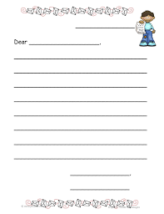
To help parents/carers keep up-to-date with news, trips, etc that are taking place in school for their children, all letters are sent out electronically via MCAS. However, we do also update the school website with letters that are sent home.

For letters that are for the whole school, please go to the parents/Carers tab then Newsletters and Information and click either Information Letters or Newsletters to find what communications have been sent.
Spalding Parish C of E Day School - Newsletters and Information

For letters that are specific to a year group, please click the Learning tab Spalding Parish C of E Day School - Learning and choose the year group you need from the drop down list. Scroll down and click the link for ‘Information Letters’.

We also print spare copies of letters and these are kept in the carousel in the waiting area at the Reception for parents/carers to take a copy should they need to.

School Milk

Milk is a vital contributing factor to the growth of good strong bones and teeth and therefore it is important to a growing child. A 189ml carton of milk provides half the daily requirement of calcium of a 6 year old child (The Dairy Council).

Under the Nursery Milk Scheme, milk is offered to children in the Foundation Stage who are still 4 years old for the whole of the following term. Milk is also offered throughout school to children who qualify for Free School Meals (different to Universal Infant Free School Meals).

A portion of fresh, chilled milk at mid-morning break provides protein, calcium and other vital nutrients, important for your child's growth and development. It's also a great way to bridge the gap between breakfast and lunch, re-hydrating your child and helping them to concentrate in class.

All children’s milk is refrigerated on receipt of the delivery in the early morning and is kept chilled until required at break time. Milk may be ordered on a termly basis for EYFS and Key Stage 1 children only. In the interest of children’s health, milk is semi-skimmed for children.

As stated previously school milk is FREE for children under 5 and FREE for children receiving and/or entitled to Free School Meals.

When your child turns 5, you have the option to pay for their milk directly through Cool Milk.

Please follow the registration process below to continue milk provision after your child’s 5th birthday.

- Visit www.coolmilk.com as soon as possible and select "Register your child for milk here", then follow the on-screen instructions to register and pay

When your child is over 5 and if they are entitled to benefit-based Free School Meals, school will fund the cost of their milk on your behalf.

Should you have any queries regarding your child's registration or milk supply, please do not hesitate to contact Cool Milk directly at customerservices@coolmilk.com or call 0844 854 2913.



Treats for Children

The school fully acknowledges that sometimes families want to send in treats for such things as birthdays. These are special days for children and are often marked in school by singing ‘Happy Birthday’ etc. However, as a result of the reasons listed below, we would ask that you refrain from sending in treats to be distributed to the whole class:

- To support the increasing number of children who have allergies with ingredients of cakes, treats and sweets etc. often unclear, particularly when unpackaged;

- To support wishes of those parents who have specifically requested that their child is not given any treats for which they have not given their prior consent;

- To avoid creating a sense of expectation within classes that each child should bring ‘birthday treats’ to share with their peers.

There may be occasions during the year where the class teacher might provide food items for the children as part of the curricular provision for the class. Examples of these might include home baked produce that the children have been involved in preparing, a fruit party, drinking fruit smoothies, sampling the produce from other countries and some Fairtrade products. You will be informed about these occasions in advance through our termly curriculum guidelines.

If you do have any questions or queries, please do not hesitate to get in touch with myself or a member of the Senior Leadership Team.

Lincoln Anglican Academy Trust

Raising a Concern in our School
Although we work very hard as a school, there are times when you may wish to raise a question or concern. Our aim is to resolve all concerns quickly and sympathetically. So that we can deal with this in the most effective way, we have a protocol, across all schools in our Trust, which we would ask that all parents follow.

- We would respectfully ask that you do not email the Head Teacher or Deputy Head directly as it is possible that your email will not be seen for some time due to workload.

- Please do not email teachers directly either as they are busy teaching and, similarly, may not see your email.

Instead, please follow this protocol, also detailed on the school website, under the parent pages Spalding Parish C of E Day School - Parent/Carers.

- If the issue is regarding a Teaching and Learning aspect of your child's provision, please arrange to meet with the right class teacher by contacting the school office either by telephone 01775722333 or email enquiries@spaldingparish.laat.co.uk stating your specific query, giving a reasonable time for the teacher to respond given their teaching commitments.

We will commit to responding within 48 hours as far as is reasonably practicable.

- If the issue is regarding Safeguarding, then please ask to speak to Diane Mulley or Emily Hill who are the designated personnel for Safeguarding.

- After meeting with the class teacher, please allow a reasonable time for your issue to be resolved. It may be that the teacher wishes to speak to a colleague, your child or other children.

- If, after point 1 and 3, you are still not satisfied with the outcome, please contact the school office and request a meeting with the Deputy Head Teacher Emily Hill.

- If, after point 1, 3, 4, you remain unsatisfied, then please contact the school office to request an appointment or telephone call with the Head Teacher Diane Mulley, at a time which is mutually convenient. It may not be possible to see/talk with her the same day and an appointment will not be offered, unless previous points have been carried out.

- If, after speaking with the Headteacher Diane Mulley, you remain unsatisfied, then please follow the Trust’s complaints procedure which can be viewed here https://thelaat.co.uk/policy-documents/ or ask for a paper copy from the school office.

Lincoln Anglican Academy Trust

Privacy Notice (How we use pupil information) for Pupils and Parents (adopted and issued to parents/carers on 2nd December 2019)

Under data protection law, individuals have a right to be informed about how the school uses any personal data that we hold about them. We comply with this right by providing ‘privacy notices’ (sometimes called ‘fair processing notices’) to individuals where we are processing their personal data.

This privacy notice explains how we collect, store and use personal data about pupils.

Spalding Parish Church of England Day School are the ‘data controller’ for the purposes of data protection law.

The role of the Trust’s Data Protection Officer is overseen by Satswana info@satswana.com

The categories of pupil information that we collect, hold and share include:
- Personal information (such as name, date of birth and address);
- Characteristics (such as gender, ethnicity and disability);
- Information relating to episodes of being a child in need (such as referral information, assessment information, Section 47 information, Initial Child Protection information and Child Protection Plan information);
- Episodes of being looked after (such as important dates, information on placements);
- Outcomes for looked after children (such as whether health and dental assessments are up to date, strengths and difficulties questionnaire scores and offending);
- Adoptions (such as dates of key court orders and decisions);
- Care leavers (such as their activity and what type of accommodation they have);
- Attendance information (such as sessions attended, number of absences and absence reasons);
- Assessment information (such as internal tests, pupils progress information and public examination results);
- Medical information (such as allergies to food, medication that a pupil may require, medical incidents that may have occurred inside or outside of school, records when a pupil has received first aid treatment);
- Special Educational Needs and Disabilities information (such as specific learning difficulties, specific medical needs, previous learning or medical needs);
- Safeguarding information (such as records of concerns, timelines of events, safeguarding referrals, early help assessments, team around the child records, child in need and child protection records);
- Behaviour information (such as rewards, achievements, incident slips and exclusions);
- Epep information including targets set.

Why we collect and use this information
We use the pupil data:
- To support pupil learning;
- To monitor and report on pupil progress;
- To provide appropriate pastoral care;
- To assess the quality of our services;
- To comply with the law regarding data sharing.

The lawful basis on which we use this information
We collect and process information about children in our care and children to whom we provide services under Article 6, and Article 9 under GDPR. This enables the school to process information such as assessments, special educational needs requests, Departmental Censuses under the Education Act 1996 and the Education Act 2005, examination results and other such data processes that relate educational data to the individual within the requirements for the school to provide education for the individual.

Collecting pupil information
Whilst the majority of pupil information you provide to us is mandatory, some of it is provided to us on a voluntary basis. In order to comply with the General Data Protection Regulation, we will inform you whether you are required to provide certain pupil information to us or if you have a choice in this.

Storing pupil data
We hold children in need and children looked after data in line with our Data Retention Guidelines which can be asked for on request.

Who we share pupil information with
We routinely share this information with:
- Department for Education (DfE)
- Local Authority
- Police and Law Enforcement
- Children and Young Peoples Nurses
- National Health Service (NHS)
- Education Welfare Officer
- Social Services

Why we share pupil information
We do not share information about our pupils with anyone without consent unless the law and our policies allow us to do so.

We share pupils’ data with the Department for Education (DfE) on a statutory basis. This data sharing underpins school funding and educational attainment policy and monitoring.

We are required to share information about our pupils with the (DfE) under regulation 5 of The Education (Information About Individual Pupils) (England) Regulations 2013.

Data collection requirements:
To find out more about the data collection requirements placed on us by the Department for Education (for example; via the school census) go to https://www.gov.uk/education/data-collection-and-censuses-for-schools.

Youth support services

Pupils aged 13+
Once our pupils reach the age of 13, we also pass pupil information to our local authority and/or provider of youth support services as they have responsibilities in relation to the education or training of 13-19 year olds under section 507B of the Education Act 1996.
This enables them to provide services as follows:
- Youth Support Services
- Careers Advisers
A parent or guardian can request that only their child’s name, address and date of birth is passed to their local authority or provider of youth support services by informing us. This right is transferred to the child / pupil once he/she reaches the age 16.

The National Pupil Database (NPD)
The NPD is owned and managed by the Department for Education and contains information about pupils in schools in England. It provides invaluable evidence on educational performance to inform independent research, as well as studies commissioned by the Department. It is held in electronic format for statistical purposes. This information is securely collected from a range of sources including schools, local authorities and awarding bodies.

We are required, by law, to provide information about our pupils to the DfE as part of statutory data collections such as the school census and early years’ census. Some of this information is then stored in the NPD. The law that allows this is the Education (Information About Individual Pupils) (England) Regulations 2013.

To find out more about the NPD, go to https://www.gov.uk/government/publications/national-pupil-database-user-guide-and-supporting-information.

The department may share information about our pupils from the NPD with third parties who promote the education or well-being of children in England by:
- Conducting research or analysis;
- Producing statistics;
- Providing information, advice or guidance.

The Department has robust processes in place to ensure the confidentiality of our data is maintained and there are stringent controls in place regarding access and use of the data. Decisions on whether DfE releases data to third parties are subject to a strict approval process and based on a detailed assessment of:
- Who is requesting the data;
- Purpose for which it is required;
- Level and sensitivity of data requested;
- Arrangements in place to store and handle the data.

To be granted access to pupil information, organisations must comply with strict terms and conditions covering the confidentiality and handling of the data, security arrangements and retention and use of the data.

For more information about the department’s data sharing process, please visit: https://www.gov.uk/data-protection-how-we-collect-and-share-research-data

For information about which organisations the department has provided pupil information, (and for which project), please visit the following website: https://www.gov.uk/government/publications/national-pupil-database-requests-received

To contact DfE: https://www.gov.uk/contact-dfe

Requesting Access to your Personal Data
Individuals have a right to make a ‘subject access request’ to gain access to personal information that the school holds about them.

Parents/carers can make a request with respect to their child’s data where the child is not considered mature enough to understand their rights over their own data (usually under the age of 12) or where the child has provided consent.
Parents also have the right to make a subject access request with respect of any personal data the school holds about them.

If you make a subject access request, and if we do hold information about you or your child, we will:
- Give you a description of it
- Tell you why we are holding and processing it, and how long we will keep it for,
- Explain where we got it from, if not from you or your child
- Tell you who it has been, or will be, shared with
- Let you know whether any automated decision-making is being applied to the data, and any consequences of this
- Give you a copy of the information in an intelligible form

Individuals also have the right for their personal information to be transmitted electronically to another organisation in certain circumstances.

If you would like to make a request please contact Satswana info@satswana.com

If a request is made during the school holidays, please be aware that there may be a delay in the request being processed. For further information and for a copy of the Subject Access Request form, please see the LAAT Data Protection and Freedom of Information Policy, a copy of which can be found here: https://www.spaldingparish.lincs.sch.uk/page/?title=Policies&pid=10

Parents/carers also have a legal right to access their child’s educational record. To request access please contact Diane Mulley, Head Teacher.

You also have the right to:
- Object to processing of personal data that is likely to cause, or is causing, damage or distress;
- Prevent processing for the purpose of direct marketing;
- Object to decisions being taken by automated means;
- In certain circumstances, have inaccurate personal data rectified, blocked, erased or destroyed;
- Claim compensation for damages caused by a breach of the Data Protection regulations.

If you have a concern about the way we are collecting or using your personal data, we request that you raise your concern with us in the first instance. Alternatively, you can contact the Information Commissioner’s Office at https://ico.org.uk/concerns/.

Contact
If you would like to discuss anything in this privacy notice, please contact:
Diane Mulley - diane.mulley@spaldingparish.laat.co.uk

Expected Behaviour of Parents/Carers

We warmly welcome visitors to our school.

We will act to ensure it remains a safe place for pupils, staff and all other members of our community. If a parent/carer has concerns we will always listen to them and seek to address them following our ‘How to Raise a Concern Guidance’ and via our Trust Complaints Policy.

In line with our Code of Conduct for Parents/Carers, abusive, threatening or violent behaviour will not be tolerated and you may be asked to leave the site.

Ephesians 4:2

Be completely humble and gentle;

be patient, bearing with one another in love.

Lincoln Anglican Academy Trust
Parent and Carers Code of Conduct

Ephesians 4:2: Be completely humble and gentle; be patient, bearing with one another in love.

Introduction
We are very fortunate to have a supportive and friendly parent body across our schools and Trust. Our parents recognise that educating children is a process that involves partnership between parents, class teachers and the school community. As a partnership, our parents/carers will understand the importance of a good working relationship to equip children with the necessary skills for adulthood. For these reasons we continue to welcome and encourage parents/carers to participate fully in the life of our school.

Purpose and Scope
The purpose of this policy is to provide a reminder to all parents, carers and visitors to our school about the expected conduct when engaging with anyone within the School Community in person, either on or off site, or through any other means (e.g. emails and/or social media). This is so we can continue to flourish progress and achieve in an atmosphere of mutual understanding.

Guidance
We expect parents, carers and visitors to:
- Respect the caring ethos and values of our school
- Understand that both teachers and parents need to work together for the benefit of their children.
- Demonstrate that all members of the school community should be treated with respect and dignity therefore set a good example in their own speech and behaviour.
- Use social media and associated messenger services for appropriate and respectful communication regarding the school, staff and families.
- Seek to clarify a child’s version of events with the school’s view in order to bring about a peaceful solution to any issue.
- Correct own child’s behaviour especially in public where it could otherwise lead to conflict, aggressive behaviour or unsafe behaviour that could bring the school into disrepute.
- Approach the school to help resolve any issues of concern.
- Avoid using staff as threats to admonish children’s behaviour.

In order to support a peaceful and safe school environment the school cannot tolerate parents, carers and visitors exhibiting the following:
- Disruptive behaviour which interferes or threatens to interfere with the operation of a classroom, an employee’s office, office area or any other area of the school grounds including team matches.
- Using loud/or offensive language, swearing, cursing, using racist, homophobic language or appearing intimidating or aggressive. Racist, homophobic or otherwise illegal language will be reported to the relevant authorities.
- Threatening to do actual bodily harm to a member of school staff, Governor, visitor, fellow parent/carer or student regardless of whether or not the behaviour constitutes a criminal offence.
- Damaging or destroying school property.
- Abusive or threatening e-mails or text/voicemail/phone messages or other written communication.
- Defamatory, offensive or derogatory comments regarding the school or any of the students/parent/staff, at the school on social media or messenger services. (See Appendix 1). Any concerns you may have about the school should be made following the schools’ ‘Raising a concern’ protocol found on the parent pages of the school’s website Spalding Parish C of E Day School - Parent/Carers and also detailed in Appendix 2. It is essential that all concerns are made following this process so that so they can be dealt with fairly, appropriately and effectively for all concerned.
- The use of physical aggression towards another adult or child.
- Approaching someone else’s child in order to discuss or chastise them because of the actions of this child towards their own child. (Such an approach to a child may be seen to be an assault on that child and may have legal consequences).
- Smoking and consumption of alcohol or other drugs whilst on school property.
- Dogs being brought on to school premises.

Should any of the above behaviour occur on school premises the school may feel it is necessary to contact the appropriate authorities, including the Police, and if necessary, even ban the offending adult from entering the school grounds (see LAAT Harassment, Persistent and Vexatious Complaints Policy of staff including aggressive behaviour from parents/carers and visitors to the school).

We trust that parents and carers will assist our school with the implementation of this policy and we thank you for your continuing support of the school.

We ask that all interactions, in line with our Parent Code of Conduct, with the school, are positive, respectful and polite, recognising the professionalism and dedication of the staff. We will not tolerate any form of verbal or physical abuse or aggression.

Appendix 1:

Use of Social Media
When used positively, social media can be a force for good and can be a highly effective way of communication between a school and its community.

However, inappropriate use of social media, such as posting slanderous material about the school or individual members of staff will be treated with utmost seriousness.

Websites are being used increasingly to fuel campaigns and complaints against schools, Headteachers, school staff, and in some cases other parents/students.

The Trust considers the use of social media websites being used in this way as unacceptable and not in the best interests of the children or the whole school community. Any concerns you may have must be made through the appropriate channels by following the school’s guidance on How to Raise A Concern so they can be dealt with fairly, appropriately and effectively for all concerned.

In the event that any student or parent/carer of a child/ren being educated in the school is found to be posting libellous or defamatory comments on social media sites or associated messenger services, they will be reported to the appropriate 'report abuse' section of the network site. All social network sites have clear rules about the content, which can be posted, on the site and they provide robust mechanisms to report contact or activity which breaches this.

The school and Trust will also expect that any parent/carer or student removes such comments immediately. In serious cases the school will also consider its legal options to deal with any such misuse of social networking and other sites.

Additionally, and perhaps more importantly is the issue of cyber bullying and the use by one child or a parent to publicly humiliate another by inappropriate social network entry. We will take and deal with this as a serious incident of school bullying. Thankfully such incidents are extremely rare. We would expect that parents would make all persons responsible for collecting children aware of this policy.

