On Sunday 2nd April, Miss Siddall is running the London Landmarks Half Marathon to raise money for the National Literacy Trust.
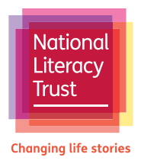

We will be hosting a cake sale in school on Thursday 30th March to help raise some money for such a worthy cause.

KS2 Playground, outside the Year 6 classrooms
Thursday 30th March from 3:10pm

Please bring any cake donations to Year 6 on the morning of
Thursday 30th March, ready for the sale after school.

(We are grateful of all donations to the sale, #but please remember that we are a nut-free school)

Thank you

