****Spalding Parish Church of England Day School

**Our School**

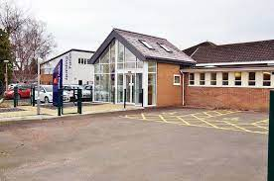

Welcome to our school family. Here are some of the people that you will meet at our school and what their special job is.

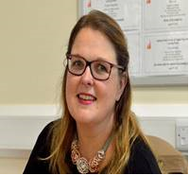

**Mrs Mulley** is our Head Teacher. She works very hard to make sure that everything at our school is fabulous.

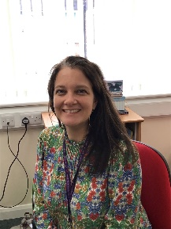

**Mrs Hill** is our Deputy Head. Mrs Hill helps to keep everyone in our school safe.

**Miss Bird** is our Assistant Head Teacher. She loves reading and is in charge of making sure that the learning in school is packed with fun!

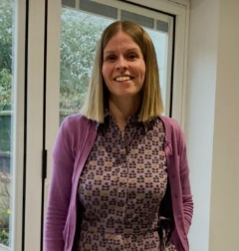

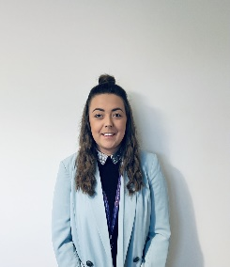

**Miss Hardy** is our Assistant Head Teacher and SENCO. She is responsible for making sure that children who need a little more support receive it.

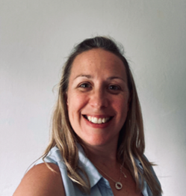

**Mrs Cooper** is one of the EYFS Class Teachers but is also responsible for leading EYFS. She helps to make learning fun especially Phonics and Reading throughout the school.

**Our Fabulous EYFS Team**

Every day, the people below will be there to greet you and make sure that you have a brilliant day. They will help you if you find something hard, if you fall over but most importantly, they will make you smile!

**Teachers**

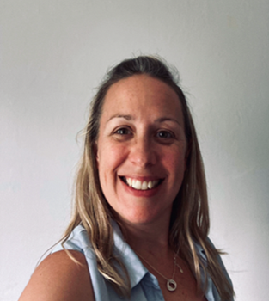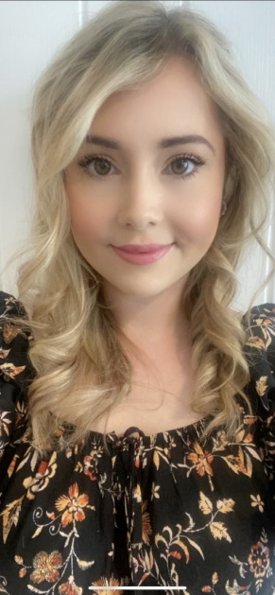

Hello, my name is Miss Baker. Before teaching I was a nurse.  I live with my two beautiful Ragdoll cats and I like to spend time with my family and friends and to be outdoors.

Hello, my name is Mrs Cooper. I live with my husband and my three children. We have a dog called Sasha and 3 cheeky rabbits. I love singing and dancing and I can’t wait to join you on your learning journey.

**Teaching Assistants**

Mr Waldron and Mrs Egleton both work in EYFS (Early Years Foundation Stage). Their favourite part of the day is independent learning time when they get to play alongside you and help your ideas come to life.

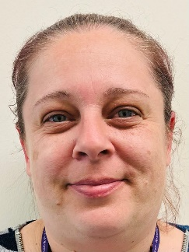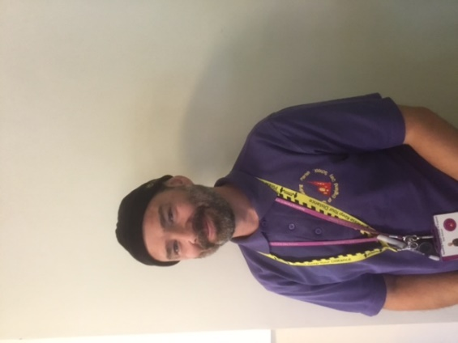

**Our Learning Spaces**

**Sky Room**

Do you love to ask questions about how the world works? Then you will love to explore this room! In here you can make experiments, program the Beebots and use your observational skills to answer your own questions. You can use your knowledge of the world and maps to create cities and towns with the building blocks and cars.

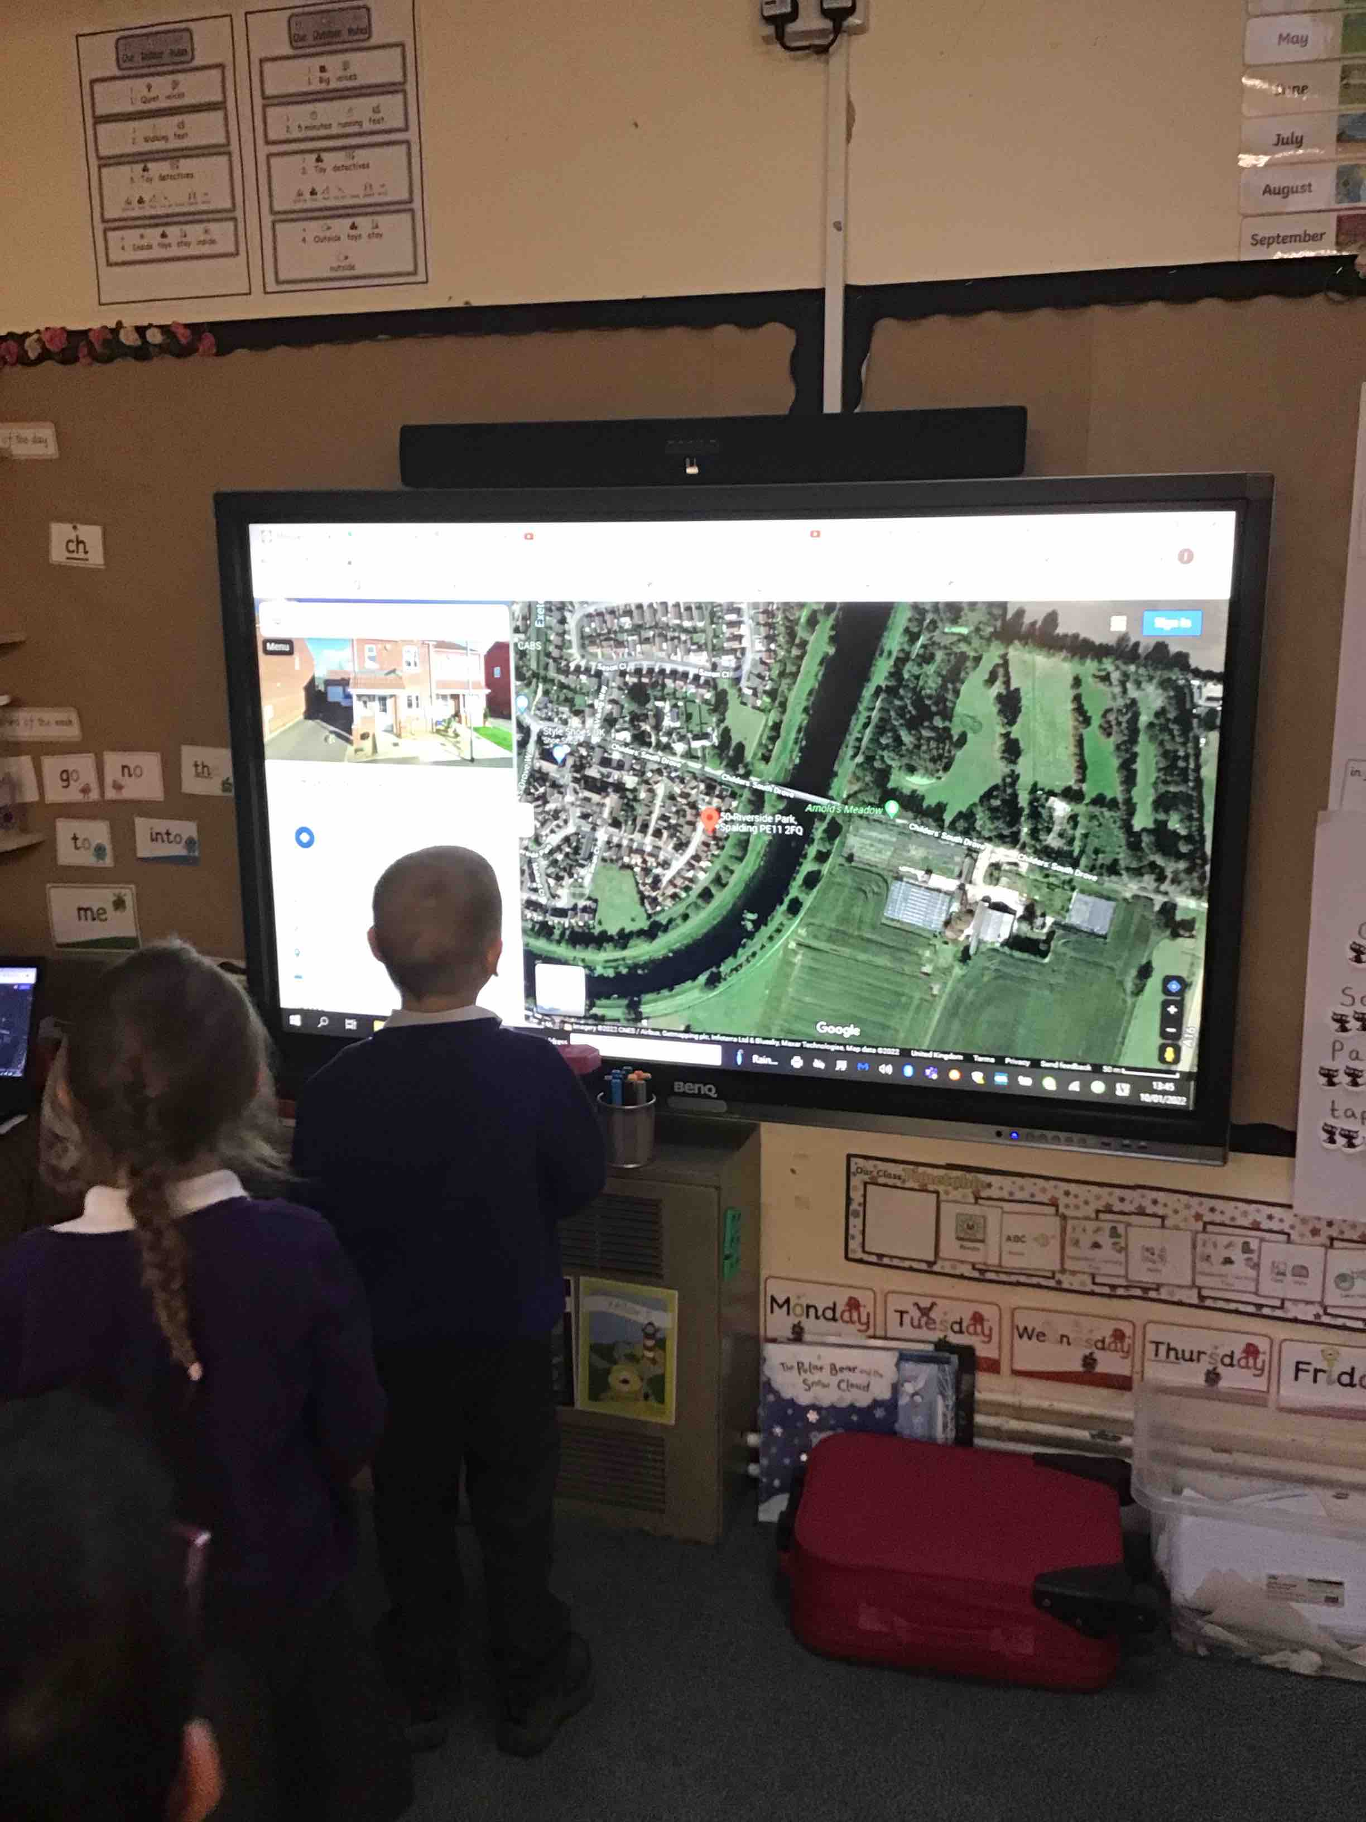

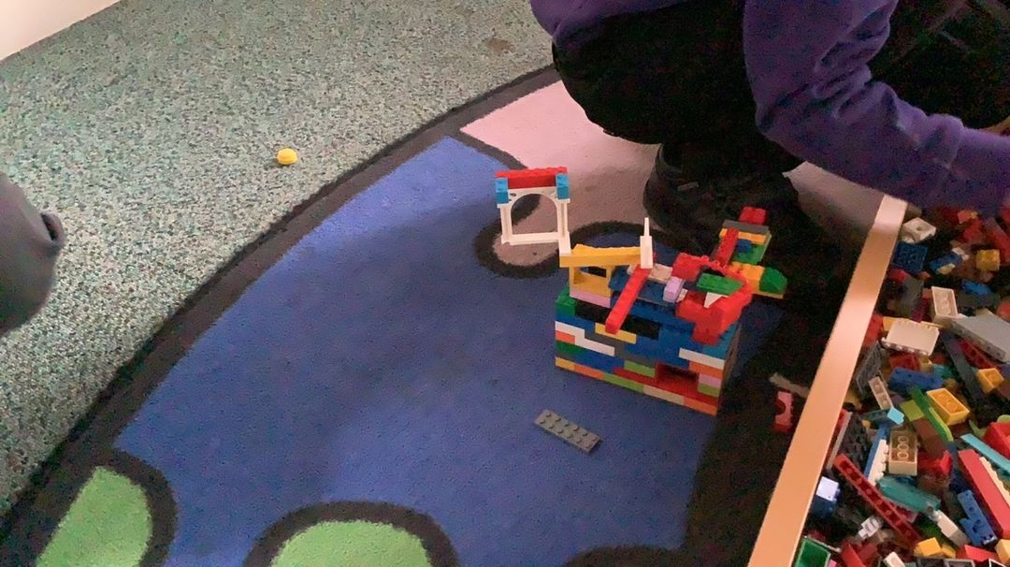

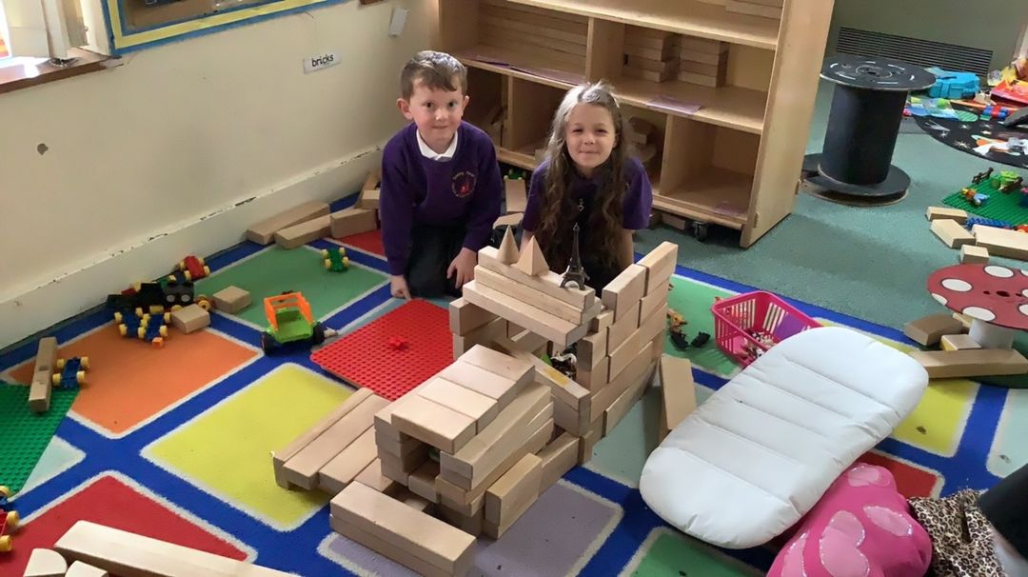

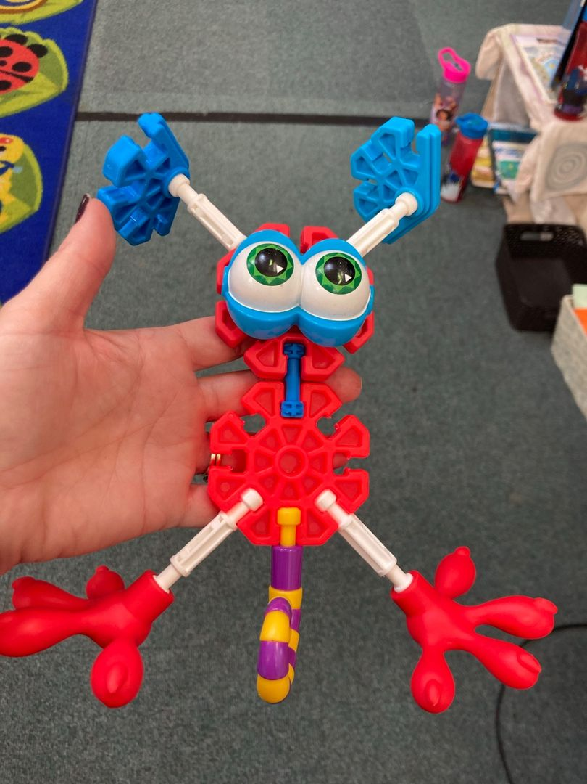

**Land Room**

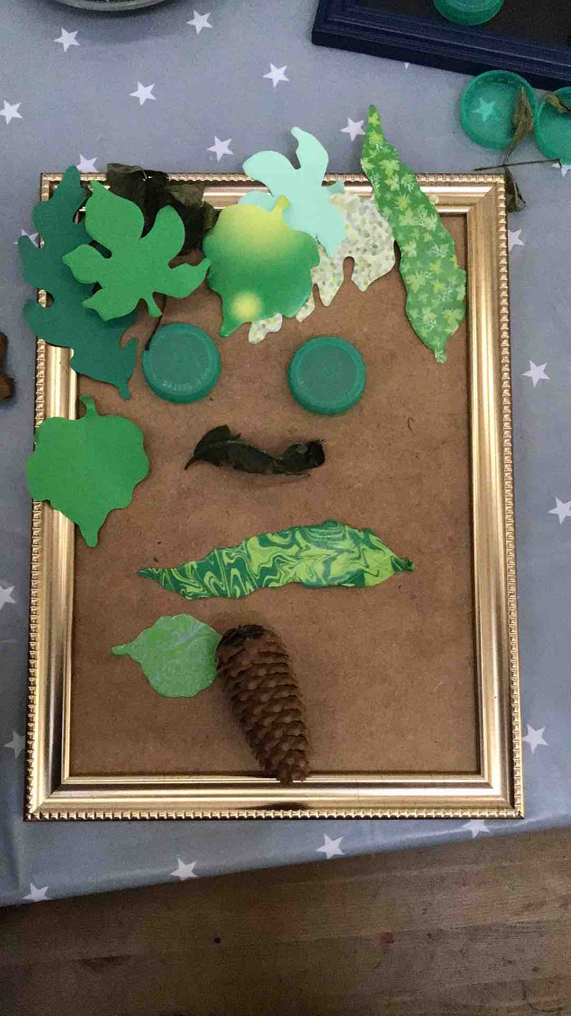Do you enjoy being creative? In this room you can develop your creativity skills and explore how to express yourself. Maybe you want to put on a show, develop your drawing and painting skills or recreate famous pieces of work! In here you can explore stories with your friends and recreate them or use the natural world to create you own masterpiece!

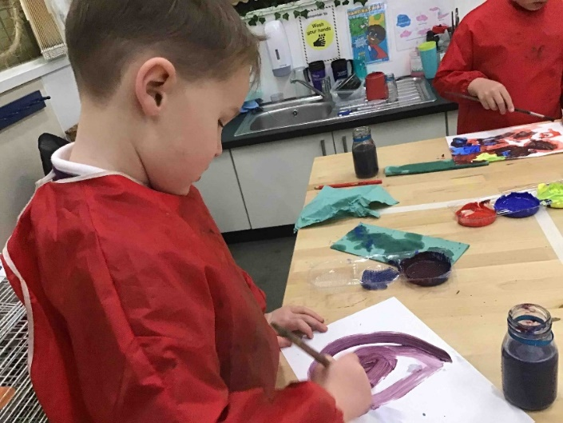

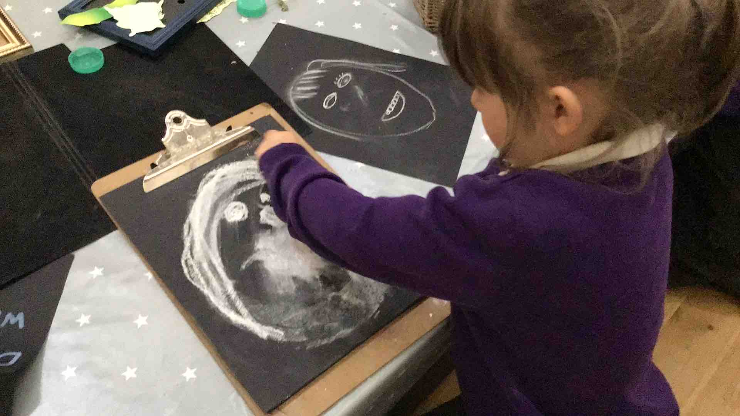

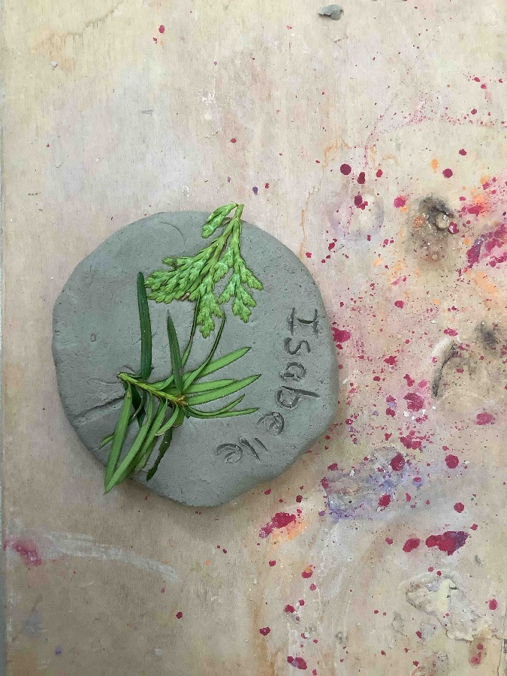

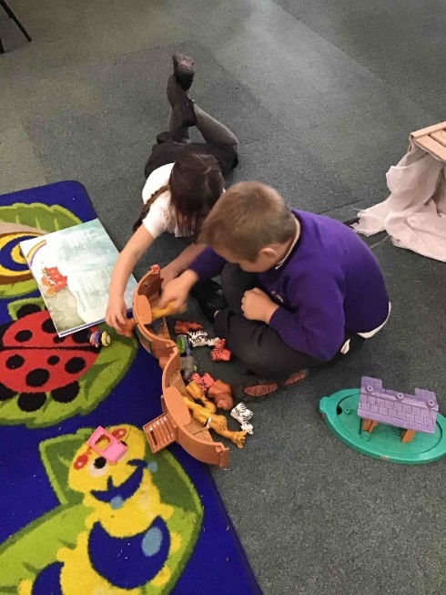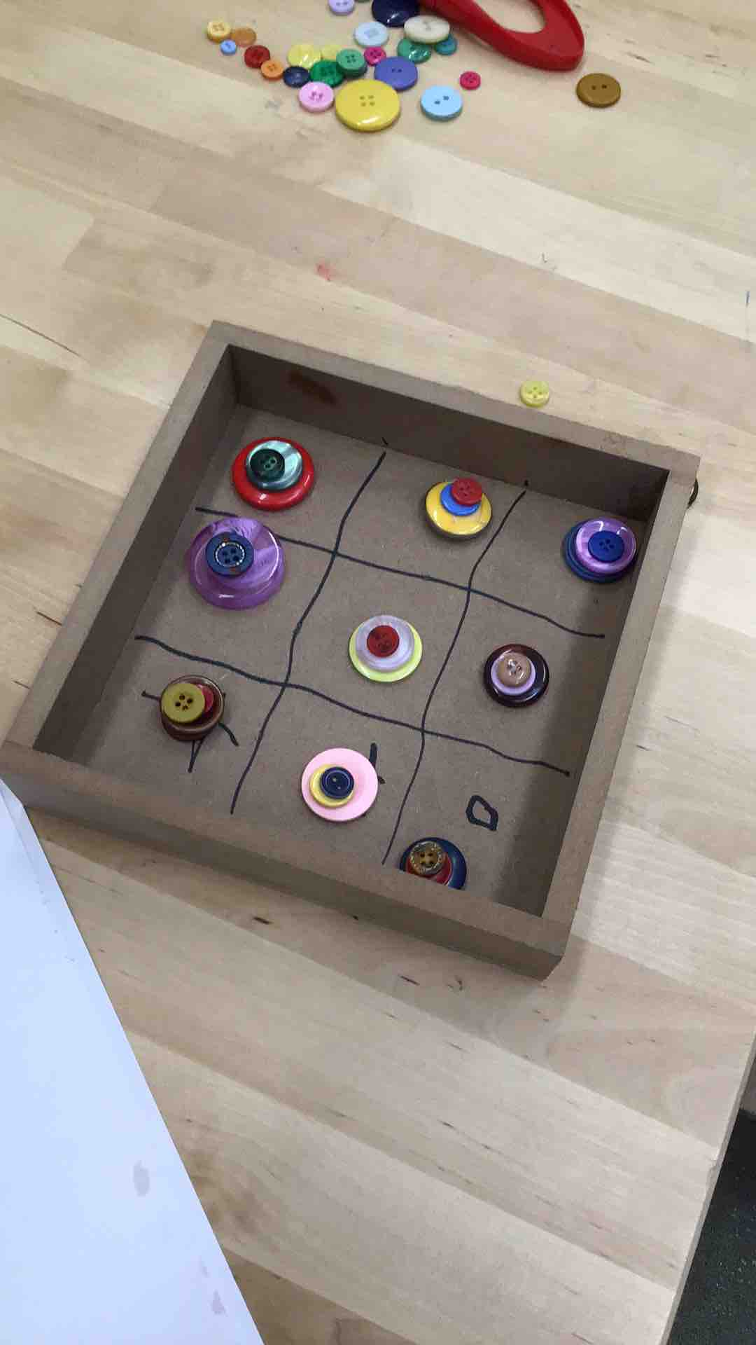

**Sea Room**

Do you prefer activities where your mind and body can be calm? The Sea Room provides the opportunity for you to sit and be reflective. In this room we really promote using all of our senses to access the world around us through a sensory approach. The use of lighting helps to create a sense of calm and relaxing music supports this.

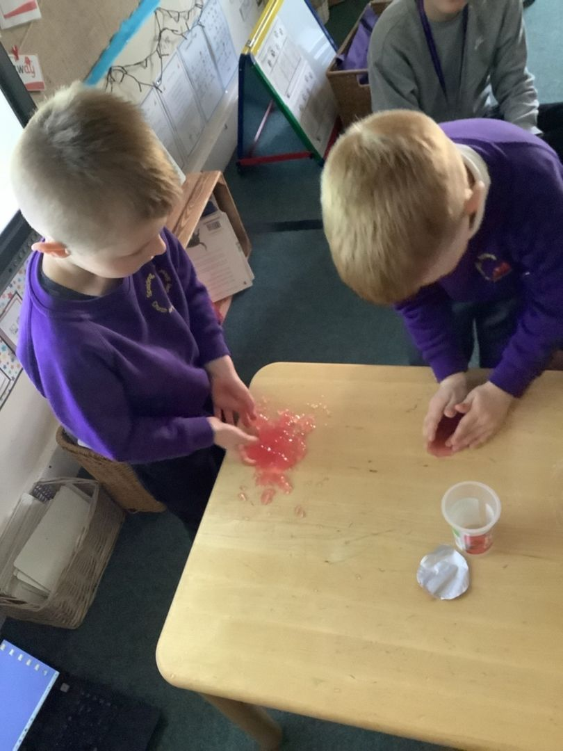

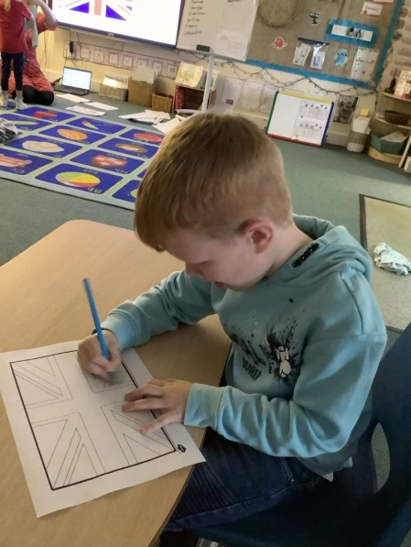

**English and Maths**

You will find English and Maths activities in all of the rooms that you explore.

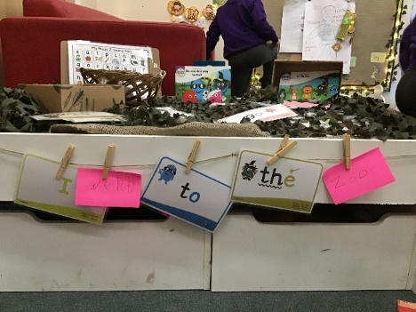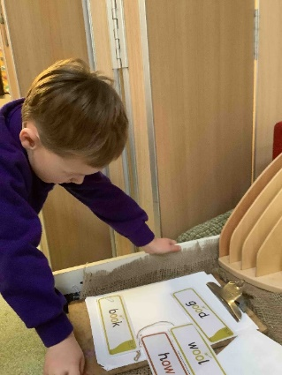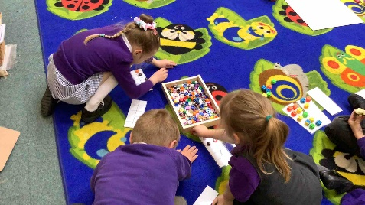

**Outside**

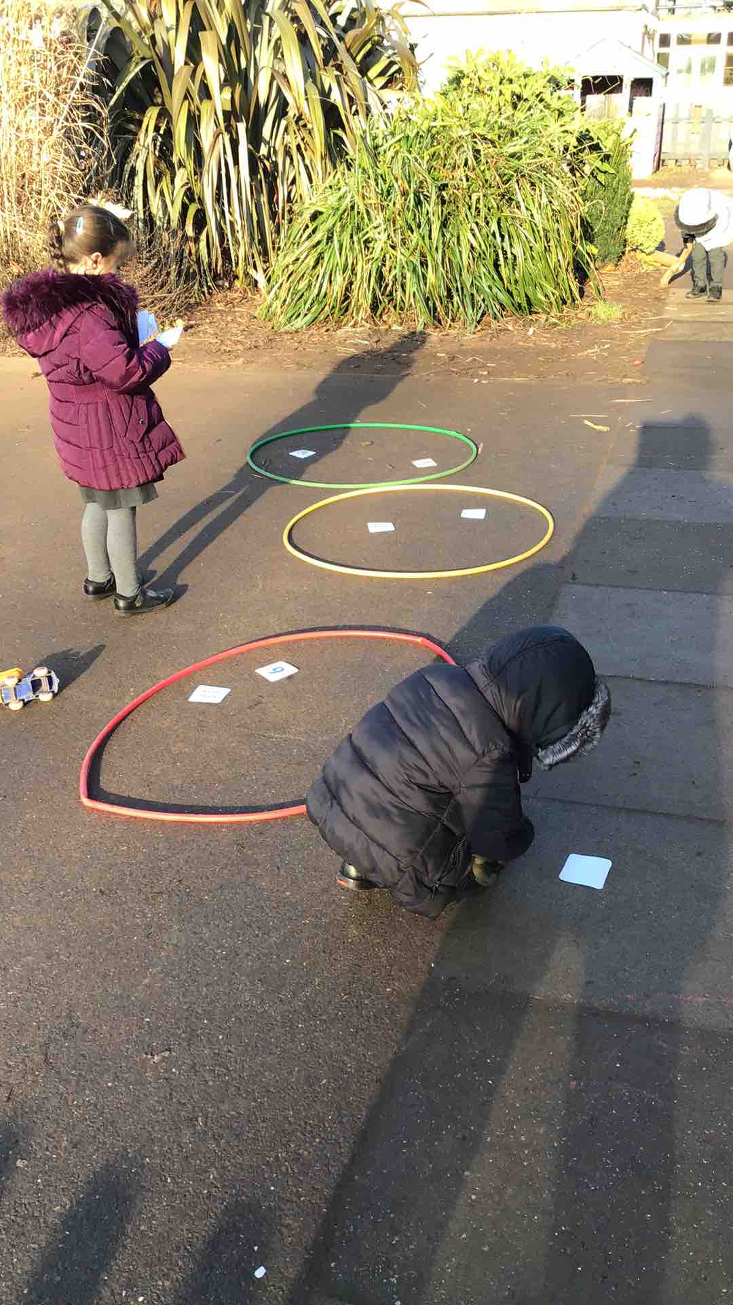All of the adults love learning outside! I wonder if you can see somewhere where you would like to explore?

